JUNIOR DOCTOR’S FORUM - Guy’s & St. Thomas’ NHS Foundation Trust

Minutes of the Meeting held on 26th March 2018, South Wing Lecture Theatre, St Thomas’ with video link to the Sherman Centre, Guy’s Hospital.

PRESENT
Rosalinde Tilley (GOS) Guardian of Safe Working (GOS - Chair)
Georgina Charlton (GC) Deputy Freedom to Speak Up Guardian
Lisa Campbell (LC) Project Support Officer (Minutes)
Ian Rothwell Medical HR
Kevin O’Kane LNC Chair
Trainee representatives from:
Oncology
Anaesthetics
Radiology
GPVTS
O&G
Paeds Neuro
Cardiac Surgery
Critical Care
Histopathology
Vascular
Plastics
Paeds Surgery
Respiratory/GIM
Gastroenterology
Allergy
Dermatology
ENT
Urology

1. APOLOGIES
Pauline Flockhart, AAU, Infection

2. MINUTES & MATTERS ARISING

GOS welcomed everybody to the meeting.

Minutes and Actions from the last meeting were discussed and agreed.

3. REPORT FROM GOS

- Exception Reporting frequency Dec 17-Mar 18

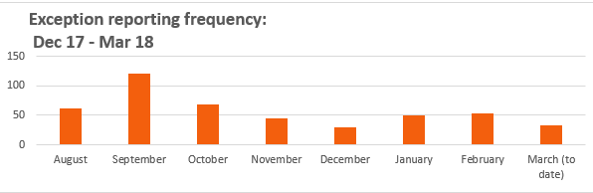

- Reason’s for exception reporting

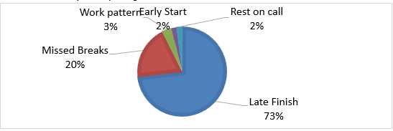

- Exception Report Outcomes Dec 2017-March 2018

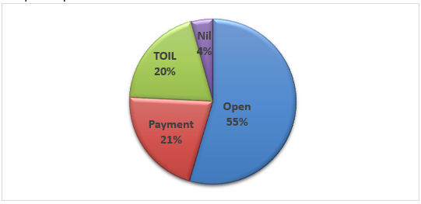

- Department Exception Report Dec 2017 -Mar 2018

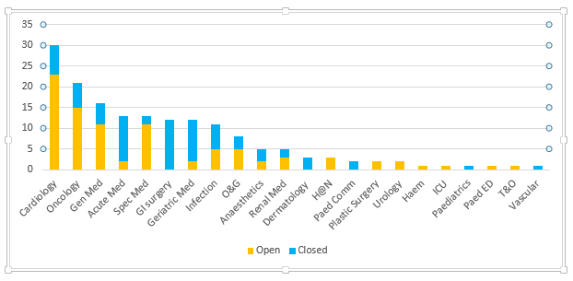

- Updates on Exception Reporting
  - Two different types of exceptions occurring on the same day should be raised separately as aetiology and remuneration may be different.
  - The number of education reports are small, as triggers are less clear than hours and rest. Work needs to be done on work schedules to clarify more specific learning objectives that can be reported against.
  - The GOS will close all ER’s with payment for trainees moving department on the 4th April e.g. CMT’s and Foundation trainees
  - If the ER for non rotating trainees are not closed, supervisors will be chased and further problems will be documented in the GOS report which is then submitted to the Board of Management.
  - Palliative Care trainees –the terms and conditions of their current contract and exception reporting will be preserved.

- Palliative Care update
    - Lead employer changes on 1st April
    - New Lead employer: St Helens and Knowsley Teaching Hospitals
    - Payroll data transferred without going outside NHS on 6th April
    - Should be seamless for trainees
    - All exception reports will be closed by GSTT GOS on 31st March
    - GOS will close all reports still open with payment
    - Any reports submitted retrospectively for March will be handled by new GOS and employer
    - For individual concerns/queries contact: Katherine Coleman : HR Project Manager Katherine.Coleman2@sthk.nhs.uk
    - New Guardian of Safe Working for Palliative Care: Peter Arthur, Peter.arthur@sthk.nhs.uk

- Palliative Care Reports: 32 reports Dec 17 – March 18

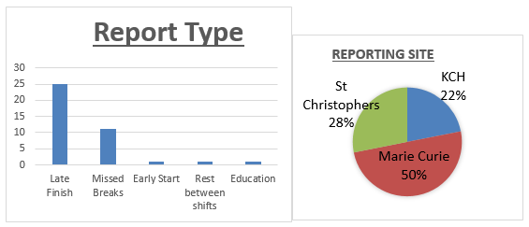

- Fines Update
  - There is about £11,000 of fines. It has been levied but not yet been paid to the GOS Fines account.
  - If a large number of trainees in one department have raised ER’s then a minimum or 25% will be ring-fenced for spending on the trainees in that department e.g. Vascular Surgery –the rep is going to discuss this with her vascular surgery colleagues to decide how to spend their money.
  - It is the responsibility of the Guardian and the Junior Doctor Forum to decide how to spend the fines.
  - The Junior Doctor Mess Fund is also providing trainees with better working conditions.
  - Some recommendations for spending fine money is on equipment such as popcorn maker, coffee maker, George Fornby Grill, sandwich maker (not possible due to fire regulations), digital radio, dyson fan. These would support trainees that are working on shift and could provide some night comfort. It was highlighted that the trainees that have raised the ER’s are possibly the ones that rarely see the Mess Room.
  - Chair LNC pointed out new recommendations for minimum environmental requirements are under review – Forum advised awaiting this prior to spending money on new facilities when the Trust would then be required to provide mandatory minimums.
  - Department simulation courses were proposed– However, the GOS pointed out that limited numbers could attend advised expenditure where more doctors could benefit
  - Financial Event -Advisor sessions-how to do your tax report/return – Agreed HR and BMA to combine on an event
  - Research posters and attend conferences – Forum agreed to provide a given support for a number of trainees especially at Foundation level. Support for the Foundation trainees who have generated the most fines was approved. Create a professional development fund, trainees can ask for up to £100
  - Access to online resources/journals. The GOS reminded the group that Up to Date is accessible via KCL (action:GOS to meet with library lead and DME)
  - The Group advised the GOS not to spend fines on disposables, but would advocate a capital expenditure (sleep aids) or supporting educational events?
- Summary of suggestions for spending money
  - Equipment- nil specific suggested
  - Educational – Finance event and Up to date access
  - Support to present research work
  - Social Events

Action: Reps to go back to departments and trainees to discuss further and then a summary to be sent to the GOS

Fines (cumulative)
Balance at end of last quarter | Fines this quarter | Spend this quarter | Balance at end of this quarter
£931.7 | £1,715.5 | £0.00 | £2,646.97

Fines by department
Department | Value of fines levied
Palliative | £910.15
Cardiology | £96.24
Vascular | £621.71
Urology | £87.80
Total | £1,715.50

- Changes to exception reporting DRS
  - Reset your own Password
  - Agreement status-trainees can now agree or disagree with the supervisors’ decision
  - Fulfilment status-if you haven’t had the time to take the TOIL then select ‘no’

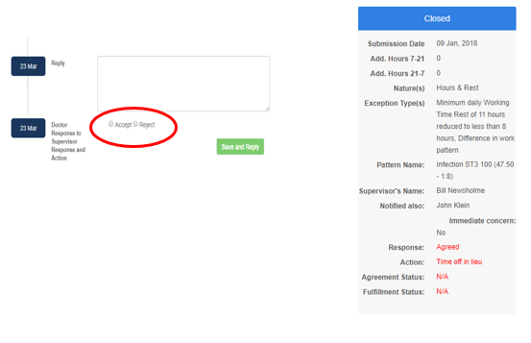

- Medical HR drop in sessions
  - Held in multiple locations across the Trust since November.
  - Numbers of doctors attending as follows:
    - November 11
    - December 2
    - January 2
    - February 0
  - Majority of queries have been interpreting payslip
  - In consequence
    - HR devising a payslip handout
    - Expanding the payslip information in the handbook.

- HR Drop ins-Future
  - STH: March 26th (STH) and April 30th - 1200-1400
  - Guys: March 27th and April 27th - 1200-1400

- How can attendance be maximised/facilitated?
  - Coincide with major teaching times/days in bigger specialties
  - Encourage JD Administrators to get in touch to arrange departmental sessions

Action: Anaesthetics rep will see if there is scope for HR to join the Anaesthetics’ meetings.

- Update from the Junior Doctor Survey and changes being implemented
- Rest facilities at night poor
  - Identifying space
  - Pull down beds, linen, phone
  - do not disturb signs
  - Any suggestions for spaces let Will Owen know?
- Belongings insecure at work
  - Centrally purchasing lockers
  - Theatres a priority
- Bleep system is inefficient
  - Task Management system being investigated
- Cultural issues
  - Understanding what good looks like
  - Good practice Guide
  - Improvement plans
- Mess in poor condition
  - Cleaned, Linen/pillows, lamps
  - Tea and coffee
  - New TV and Xbox
  - Phone charging, PCs x 10
- Any problems report to
  - JuniorDoctors'Mess@gstt.nhs.uk
  - Or email Will Owen, Chief Registrar directly

- Update from the Junior Doctor Survey and ongoing areas of work:
- Induction information
- IT system access
- Clinical area access
- Clarity of payslip
- HR issues
- Service Vs Training balance
- Mandatory training requirements

- Feedback from Trainees
- ST3-7 still not reporting. Why? Maybe negotiating changes through other routes
- Generally have less ER’s where a specialty has a robust handover system and the trainees usually finish together.
- Lack of closure on ER’s although told at the beginning that the department supports exception reporting. GOS will take up with all individuals and departments where reports are not handled in a timely manner.
- GOS would be keen to hear of any problems or discouragement with exception reporting
- There is an overall feeling that education supervisors don’t fully understand the ER system.
- GOS has been meeting smaller departments and has spoken to education supervisors and trainees. GOS is willing to visit any department to support ES and trainees.
- GOS understands that ER’s are usually the tip of the iceberg and that trainee may use the ER system as a last resort where other options have not helped
- GOS would like to improve the attendance of the Junior Doctor Forum – please contact with any ideas.
- Education Issues
    - Study Leave applications and funding queries not being responded to by PGMC
    - The Forum requested an update on study leave funding changes
    - Trainees have had problem with Intrepid not working

Action: GOS to raise with DME

Guardian of Speaking Up Update (Georgina Charlton)
- Works with the Clinical Leadership Team
- Deals with any issues of concern that they do not feel able to raise with their line manager.
- >100 cases raised to date
- If Junior doctors feel unsafe and cannot raise with ES or educational lead then Freedom to Speak Up Guardian is someone they could talk to.
- NHS England funds this full time post and is encouraging it nationally and to include GP surgeries

DATE OF NEXT MEETINGS:
- 25th June 2018 15:00pm – 17:00pm
- 17th Sept 2018 15:00pm – 17:00pm
- 10th Dec 2018 15:00pm – 17:00pm

