GUY’S AND ST. THOMAS’ NHS FOUNDATION TRUST - 18th December 2017 – 18TH March 2018
QUARTERLY REPORT ON SAFE WORKING HOURS - DOCTORS AND DENTISTS IN TRAINING:

Executive summary
Exception reporting is now open to all trainees and 90% of trust appointed juniors. Exception reporting therefore provides an overall picture of 1064 trust doctors and trainees working at GSTT. This report includes combined reporting data of the two groups of doctors.
Exception submissions have largely remained stable over the last 6 months, with 141 reports submitted in this quarter. This represents one report for every 7-8 trainees per quarter.
The Nephrology department implemented an effective plan to manage unsafe working in the previous quarter, which has seen their reporting drop from 45 previously to 5 this quarter. Likewise vascular surgery has reduced their reporting rate from 29 to zero (section Bi). The emergency medicine department has received no reports this quarter. Investigation by the GOS has revealed no major concerns. The need to facilitate second breaks during night shifts was identified as was the inadequacy of the hospital taxi service for trainees finishing at 2am.
As in previous quarters FY1 trainees were the most active reporters, submitting 39% (55) reports but comprising less than 6% of those eligible to do so. More senior trainees were less likely to report, however, for the first time a small number of reports (3) were received by trainees at registrar levels of ST6 and above (section Bii).
All reports carried over from the September to December quarter have been closed. Of the 141 reports submitted in this quarter 49 (35%) remained open when trainees were scheduled to rotate, and were reviewed and closed by the GOS with payment for remuneration. The proportion of reports closed within the contractually required period of 7 days remains static at one quarter. 14 reports (10%) are open at the end of the quarter (section Biii)

The last quarter continued the trend of additional work increasingly being remunerated with payment (63%), rather than Time off in lieu (31%). The majority of reports were in a small number of departments, where service requirements and staffing levels would not support TOIL being taken, or where departments had not managed reports in a timely way and payment has therefore been provided by the GOS.(section Biv)
Late finishes continue to form the majority of exception reports 129 (74%). Missed breaks have been reported more frequently in this quarter 32 (18%). This may reflect the winter pressures in the cardiology (10 missed breaks), oncology (9 missed breaks) and GI surgery (4 missed breaks). But is certainly an underestimate of the frequency of this problem trustwide.
There were no instances of trainees working over 72 hours in a 7 day period. Specialty trainees in infection reported 6 disturbed rest periods overnight on call.(section Bv)

In this period, some improvements have been made to the exception reporting system (DRS). Trainees are now able to reset their own passwords, have recently been provided with the ability to reject the management of a report if agreement has not been reached, and are also now able to flag when an agreed outcome has not been provided. The GOS has requested to be notified in cases of non agreement or fulfillment.
The developers have clarified the platform on which the DRS reporting system is based will be unable to support many of the features desired, and will never have capacity to link with rostering or vacancy data. Alternative reporting systems are available which potentially have these features.
Core trainees in cardiology had very high reporting rates, submitting 24 reports (17%) this quarter. Departmental supervisors managed only 5 of these reports. The remainder have been reviewed and closed by the GOS, who requested a work schedule review. The response of the faculty lead and department has been suboptimal, and the situation has been escalated to the deputy director (Miss Bell) who is working constructively with trainees to achieve the required operational and manpower changes to enable safe working. The GOS is very concerned with the working of core trainees in cardiology and considers that currently it is unsafe.
The work schedule review in elderly care commenced in the previous quarter did not achieve a plan for remediation, and has been escalated to a level 2 review. The department has taken action to secure the substantive funding for necessary temporary staff, but has not been able to agree the new work schedules and rotas that are required. The department has not demonstrated strong communication with their trainees, and the GOS can find no evidence of regular faculty meetings. The GOS remains concerned with trainees working in this department, but does not deem it to be unsafe currently.
The working pattern of FY2 doctors in urology was reported directly to the GOS, and prompted a work schedule review that was ongoing at the end of the previous quarter. Progress has been made this quarter, with a service manager providing administrative support to the rota, and a new and proactive faculty lead. However, the operational rota has been found to be at odds with the work schedule template and work is required to align these two. Local faculty meetings also need to be re-instituted. The GOS is monitoring the situation.
As the Lead employer, the trust also manages the exception reporting of the 62 specialty doctors in Palliative Care working in hospices in London. Palliative Care trainees reported 17 exceptions in this quarter down from 28 in the last quarter. Palliative Care trainees reported more missed breaks than trainees in trusts (25%) but late finishes remain the most common reason for reporting (74%). Marie Curie was again the largest reporting site accounting for 8 (47%) of reports, but this was a significant improvement on the 21 reports in the previous quarter. (section E)
Total agency and Staff Bank spends and shifts bookings have been stable over the last two quarters.(section F)The GOS can find no correlation between locum spends and the small number of HEE vacancies (section F)
396 junior doctors have undertaken additional work through the trust locum bank in this period. The GOS has determined that 388 done so within the safe working rules and have opted out of the WTR. 8 trainees have worked in excess of 56 hours per week on average, of which 3 have breached this limit even if using all their annual leave entitlement. One trainee has again worked in excess of 70 hours per week on average. The GOS acknowledges the joint responsibility for trainees and the trust in this, and urges the trust to put a system in place to prevent this in future (section G)

The total vacancy rate for junior doctors across the trust is currently unknown. HEE data reports 15 vacancies in the 275 posts rotated in this period. No correlation has been found between training post vacancies and exception reporting rates in any department, due to the large number of trust doctors participating in many rotas (section H). Trust doctor vacancies are unknown. The GOS found HEE errors accounted for all of the incidences of trainees not receiving their work schedules by the time of induction.(section I)
The trust has incurred £1715 of fines in the last two quarters. No monies have yet been spent. There has been a delay in payment of levied fines levied being paid to the GOS. The GOS will update in the forthcoming annual report.(section J)
Recommendations;
- The trust should review the performance of the designated hospital transport taxi service for all staff groups finishing shifts at unsocial
- All educational and named clinical supervisors should include data demonstrating their timely management of exception reports in their forthcoming annual appraisal.
- The GOS again advises the board to explore the costs and potential advantages of the alternative exception reporting system (Allocate).
- The trust should devise a process for managing operational rotas for doctors around rotation times, to prevent shift clashes when moving from one department to another.
- The GOS again advises the staff bank to limit trainees who have a contract for regular work to a maximum of 104 hours of work per quarter, or devise an alternative process to limit contracted and staff bank hours to within the 56 hours/week limit and prevent significant excess and unsafe working
- Structure of Report
This report utilises data from exception reporting and human resources and staff locum bank, direct contact made to the Guardian of Safe Working (from departments, supervisors, trainees and the education centre), focus groups with trainees, and the Junior Doctors Forum.

Content
A. High level data
B. Hour monitoring information - Exception reports Instances of trainees working in GSTT
- Report frequency by department
- Report frequency by grade
- Response times for managing reports
- Outcomes for reports
- Types of reports
C. Work Schedule reviews – Patterns of unsafe working in junior doctors within the trust
- Care of Elderly
- Urology
- Cardiology
D. Detailed analysis of exception reporting and work schedule reviews in Palliative Care
E. Locum bookings – Shift and spend data for Staff Bank and Agency for departments
F. Locum work – Safety assessment of additional locum work undertaken by individual trainees
G. Vacancies
H. Fines – levied by GOS under the 2016 T&CS
I. Contract Breaches
J. Junior Doctors Forum
K. Update on recommendations from previous report

A. High level data
Number of doctors & dentists in training 2016 TCS: 795

Grade | Trainee numbers
FY1 | 60
FY2 | 76
CMT | 34
CST | 16
CAT | 13
ACCS | 20
ST3+ | 514
Palliative Care ST3+ | 62
Total Trainees | 795

Number of Palliative Care doctors in training: 62
Number of trust grade doctors able to exception report: 269
Number of trust grade doctors unable to exception report: 29
Job planned time for guardian to do the role: 5PAs
Admin support provided to the guardian: 0.6 WTE Band 5 (Commenced Jan 2017)
Job-planned time for educational supervisors: 0.25 PAs per trainee (agreed).
B. Hour monitoring information
- Exception reports 18th December 2017 – 18th March 2018 by department (data table)
Exception reports by department
Specialty | Exceptions carried over | Exceptions raised Dec 17 - Mar 18 | Exceptions closed by Supervisors | Exceptions closed by GOS | Exceptions outstanding
Accident & Emergency | 0 | 0 | 0 | 0 | 0
Acute Medicine | 0 | 12 | 12 | 0 | 0
Anaesthetics | 0 | 5 | 3 | 0 | 2
Cardiology | 9 | 24 | 5 | 28 | 0
Critical Care | 0 | 1 | 0 | 1 | 0
Dermatology | 0 | 3 | 3 | 0 | 0
Elderly Care | 0 | 12 | 11 | 0 | 1
ENT Surgery | 0 | 0 | 0 | 0 | 0
Gen Medicine | 0 | 14 | 3 | 10 | 1
Oncology | 5 | 20 | 6 | 19 | 0
Specialty | Exceptions carried over | Exceptions raised Dec 17 - Mar 18 | Exceptions closed by Supervisors | Exceptions closed by GOS | Exceptions outstanding
Histopathology | 0 | 0 | 0 | 0 | 0
Infection | 1 | 10 | 9 | 0 | 2
Nephrology | 0 | 5 | 2 | 3 | 0
O&G | 0 | 9 | 3 | 0 | 6
Paed EM | 0 | 1 | 1 | 0 | 0
Paed NICU | 0 | 0 | 0 | 0 | 0
Paed Community | 0 | 1 | 1 | 0 | 0
Paed Cardiology | 0 | 0 | 0 | 0 | 0
Paed General | 1 | 1 | 2 | 0 | 0
Paed Special | 0 | 0 | 0 | 0 | 0
Paed Surgery | 0 | 0 | 0 | 0 | 0
Plastic Surgery | 3 | 0 | 0 | 3 | 0
Psychiatry | 0 | 0 | 0 | 0 | 0
Specialty | Exceptions carried over | Exceptions raised Dec 17 - Mar 18 | Exceptions closed by Supervisors | Exceptions closed by GOS | Exceptions outstanding
Specialist Med | 0 | 11 | 9 | 0 | 2
Surgery GI | 0 | 12 | 12 | 0 | 0
Orthopedics | 0 | 0 | 0 | 0 | 0
Urology | 0 | 0 | 0 | 0 | 0
Vascular surgery | 7 | 0 | 2 | 5 | 0
Hosp at Night | 3 | 0 | 3 | 0 | 0
Total | 29 | 141 | 87 | 69 | 14

- Exception reports 18th December 2017 – 18th March 2018 by department (graphically)
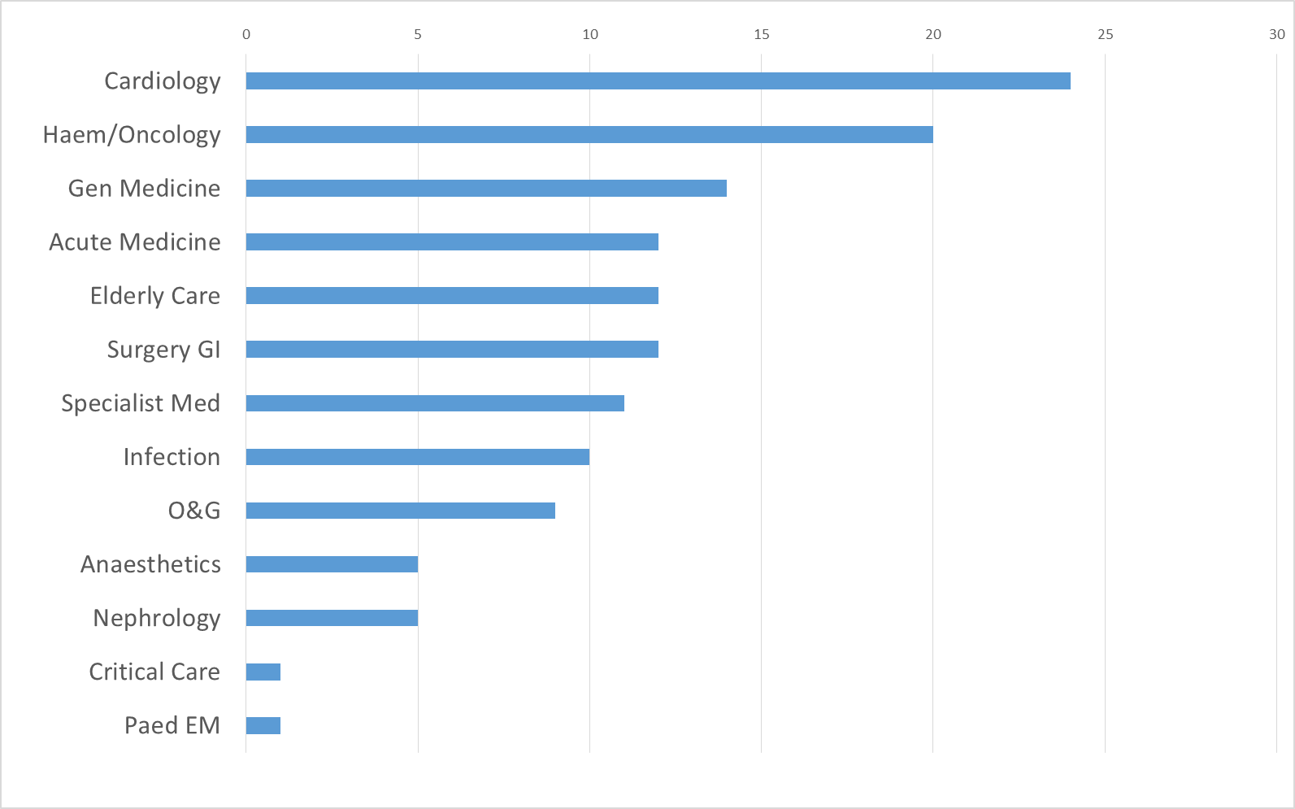
Departments with no reports not shown

- Rate of exception reporting over the quarter discussion:

The above data therefore includes all exception reporting activity of junior doctors over this period (both training and non-training) and is therefore a reflection of all junior doctors working across the trust.

The number of doctors eligible to exception report remained stable during this quarter. However, the number of exception reports dropped by 69 from 210 in the previous three month period to 141 in this quarter. This reduction is mainly due to the larger number of reports received following the major rotation in the summer of 2017. The rate of reporting thereafter has remained stable (between 40 and 50 reports per month).

Changes from previous quarter:

Nephrology was the largest reporter in the previous quarter, but has shown a significant improvement (reducing from 45 to 5 reports). This is a testament to the excellent work done by the faculty and clinical leads with their trainees, and the additional resources that the department has allocated following the work schedule review undertaken.

Vascular surgery has made significant improvements, with no reports this quarter down from 29 in the previous quarter. The GOS is satisfied that the department has a culture (set by the clinical director) which encourages exception reporting and under-reporting is similar to elsewhere in the trust.

Cardiology had very low reporting levels previously. The GOS liaised with both trainees and senior members of the directorate, and concluded this low rate was due to the culture of the department rather than a reflection of juniors working patterns. The situation has changed in the last 4-6 months, led by some senior members of the cardiovascular directorate who have encouraged reporting. Consequently, reporting has increased rapidly. All cardiology reports have been submitted by core trainees, who are clearly working in excess of their scheduled working hours. Exception reports have all been allocated to the faculty lead (instead of named clinical supervisors). This is because the department failed to produce a list of supervisors to the GOS despite repeated requests. The GOS has serious concerns about the working pattern of core trainees in cardiology, and the clinical supervision support offered currently. The faculty lead has failed to respond to any correspondence from the GOS, and the situation has been escalated through the directorate.

Oncology has again a larger number of exception reports from trainees (at FY1 – Core level) than would be expected in a department of their size. This has been a consistent feature for some quarters and the GOS documented concerns about trainees working conditions in previous reports. The department is about to undergo a major restructuring of their registrar working pattern, with senior trainees reverting to non-resident on call. The GOS believes it is necessary to see the implications of this on more junior trainees working patterns and will report in the next quarter.
Winter pressure review: Emergency medicine: Given the severe pressures on the emergency department, the GOS was concerned that no reports had been submitted by emergency medicine doctors. The GOS visited the department and spoke confidentially to a cross section of doctors (foundation to registrar level). Trainees all reported excellent support from senior staff to enable breaks to be taken and to leave on time. Occasional late finishes had occurred but were not deemed to have been significant by trainees (small, infrequent or voluntary).
One break per shift is being reliably facilitated by senior staff. However, there was a lack of knowledge (at all levels) about the need for a second break for longer shifts. Trainees felt there was scope for a second break to be taken, if they were supported by seniors aware of this entitlement. This issue has been fed back to the clinical lead who has agreed to take positive action.
Trainees who are scheduled to finish at 2am all reported frequent long waits for hospital transport home. Some trainees are also experiencing delays due to taxis transporting a number of trainees living in different locations in one car. The GOS has been made aware of other theatre staff experiencing similar problems. The ED clinical lead has agreed to encourage exception reporting by trainees for these occurrences.
Recommendation 1: The trust should review the performance of the designated hospital transport taxi service for all staff groups finishing shifts at unsocial hours.
- Exception reports 18th December 2017 – 18th March 2048 by Grade (table)

Exception reports by grade
Specialty | Exceptions carried over from last report | Exceptions raised
Specialty | Exceptions carried over from last report | Dec 17 - Mar 18
F1 | 10 | 55
F2 | 0 | 8
Core trainees | 15 | 55
ST3-5 | 4 | 20
ST 6+ | 0 | 3
Total | 29 | 141
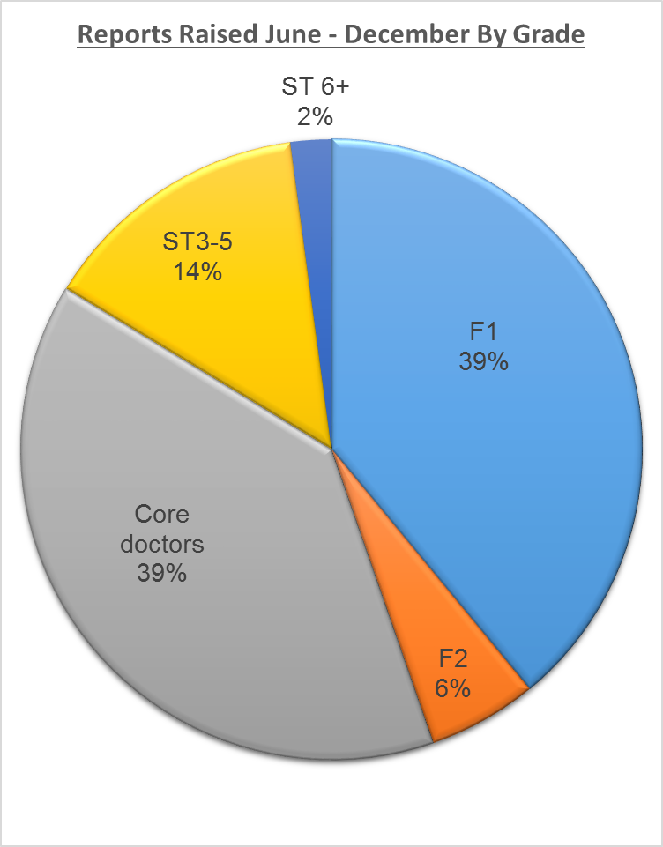

B.ii Exception reporting by Grade
The breakdown of reports submitted by junior grades was similar to previous reports.

This quarter included reports submitted by higher trainees (ST6 and above) for the first time.
The GOS has explored the reasons for low reporting rates with more senior trainees across the trust.
Reported causes include:
- Concern how reporting will be viewed, from trainees approaching consultant appointment. This view was seen as largely self generated by trainees, rather than as a result of any specific departmental actions or attitudes.
- Senior trainees attitudes to working hours, and thresholds for additional work being deemed to be significant.
- Ability to effect required changes outside of the reporting process, making reporting less important in their view. This is clearly documented in exception reports submitted by this group of trainees.
- Senior trainees wishing to limit the reporting process to highlight systematic issues rather than individual events

The GOS has noted that doctors, who have been encouraged to report in one department, maintain that culture after rotating internally in the trust. The effect of supportive departments is therefore seen more widely across the trust, spread by junior trainees in foundation years rotating frequently.
- Exception reports 18th December 2017 – 18th March 2018: Time to Closure
 | Total exceptions submitted | Closed <7 days  By ES/CS | Closed > 7 days  By ES/CS | Closed > 7 days  By GOS | Open
Dec 17 - Mar 18 | 141 | 33 (23%) | 45 (32%) | 49 (35%) | 14(10%)

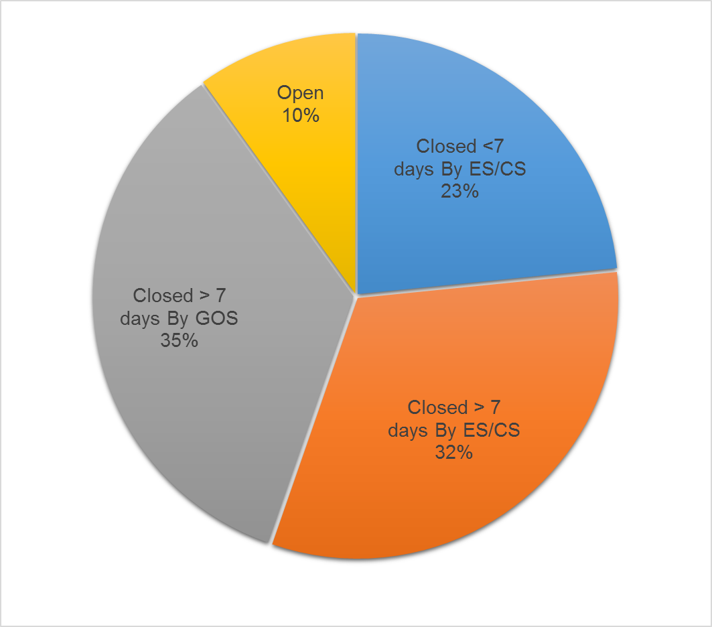

The 2016 T&CS requires exception reports to be closed within a 7 days window

 | Total reports submitted | Addressed  <48 hours | Addressed  >48 hrs <7 days | Addressed  >7 days | Remain Open
F1 | 55 | 6 (11%) | 12 (22%) | 35 (64%) | 2 (4%)
F2 | 8 | 1 (13%) | 0 | 7 (88%) | 0
Core trainees | 55 | 5 (9%) | 5 (9%) | 38 (69%) | 7 (13%)
ST3-5 | 20 | 3 (15%) | 1 (5%) | 12 (60%) | 4 (20%)
ST 6 | 3 | 0 | 0 | 2 (67%) | 1 (33%)
Total | 141 | 15 | 18 | 94 | 14

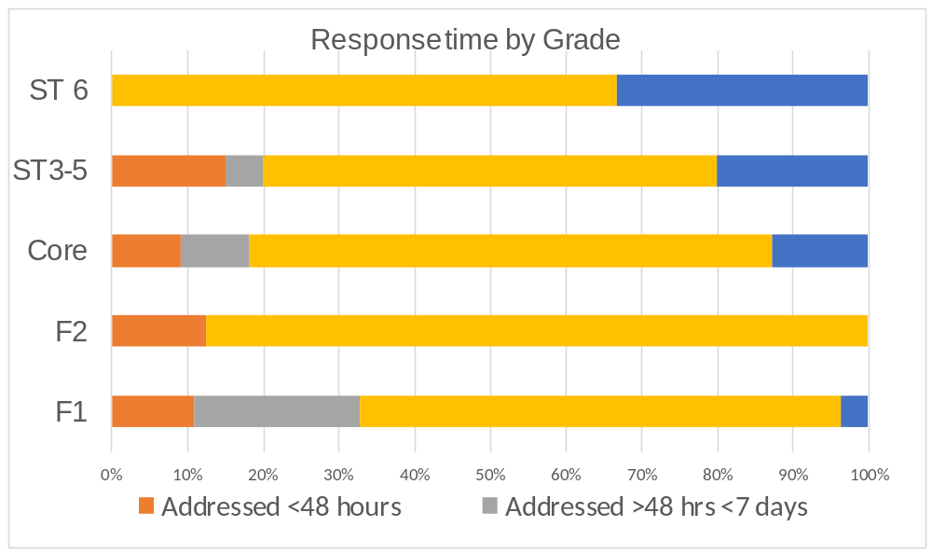
B. iii. Exception report time to closure analysis
The data reviewing time to closure of reports from this quarter mirrors preceding quarters.
The proportion of reports closed within the required 7 days remains disappointingly static at one quarter.
As per the trust protocol, any reports open when a trainee rotates department are reviewed and closed by the GOS. This applied to 49 (35%) of reports submitted in this quarter and the GOS provided payment as remuneration for all except one report. All of these reports pertained to late finishes, 20 reports also documented missed breaks. This process provides remuneration for trainees but does not address the cause of exceptions.
All reports submitted in quarter 3 have been closed. 10% percent of reports submitted this quarter remain open. This low figure is due to the end of quarter coinciding with the end of placement for Foundation/core trainees. The more frequent rotation of the core and foundation doctors’ results in fewer reports being open at the end of the quarter for this group.
The GOS closed a larger proportion of reports in some departments. This was due to one of 4 reasons;

- Reporting occurred for the first time in a department this quarter (e.g. plastic surgery). It is notable that there is a learning curve and familiarity with the process is linked to more timely closure. The GOS targets visits to these departments to provide education, and ensure supervisors are familiar with their responsibilities.
- Reports submitted just prior to trainees rotating. The GOS closes reports to facilitate timely payment. In these departments reports submitted during the quarter have largely been closed by the department and the GOS is not concerned about departmental or supervisors engagement (e.g. nephrology).
- Lack of engagement in exception reporting process by supervisors (e.g. cardiology and oncology) see section Bi. above
- Large number of supervisors involved requiring training and supporting (e.g. general medicine) The GOS will work with the new clinical director in general medicine to improve the rate of local report closure.

Recommendation 2: All educational and named clinical supervisors should include data demonstrating their timely management of exception reports in their forthcoming annual appraisal.
- Exception reports 18th December 2017 – 18th March 2017 Outcomes of closed reports
Outcomes of Reports Closed | Payment | TOIL | No action required
April – June | 42% | 39% | 19%
June – Sept | 54% | 34% | 12%
Sept – Dec | 63% | 25% | 12%
Dec - Mar | 80(63%) | 40(31%) | 7(6%)

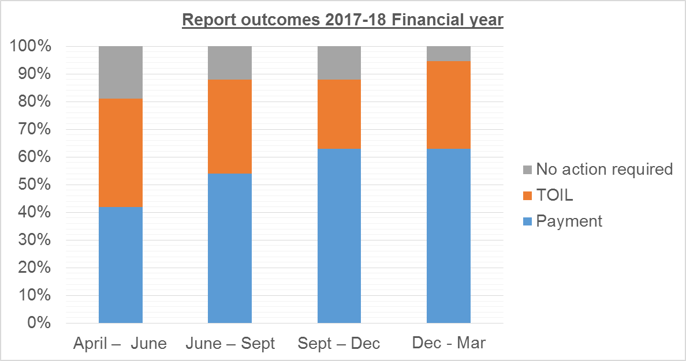

B. iv. Outcomes of exception reports
The last two quarters have continued the trend of reported additional working increasingly being remunerated with payment, rather than Time off in lieu (TOIL).
The majority of reports closed with payment by supervisors are now in a small number of departments, where service requirements and staffing levels would not support TOIL being taken without resulting in further exceptions
(e.g. GI surgery: 12 reports) .
The rate of exceptions closed with payment will also be affected by the number open when a trainee rotates. All of these valid reports are closed by GOS with payment. Reports closed by the GOS account for 60% of the payments resulting from exception reporting as well as fines.
Half of exception reports managed by supervisors result in payments. More timely management of reports by supervisors would enable TOIL to be provided more often, which many trainees would prefer, would enhance safe working and is a lower cost solution to the trust.
The GOS notes the continued decline in reports closed with no action required. Whilst this is partly due to the low numbers of “difference in work pattern” reports, it also reflects supervisors better understanding of the system and how to manage reports appropriately
The process for the payment from exception reports remains a manual and labour intensive process, there being no link between the current exception reporting and payroll systems. The GOS requested the trust explore alternative reporting systems (capable of linking to payroll). The GOS has not received an update on this recommendation (3).
The trust has requested that the GOS informs local service managers of the total cost of exception reporting in their departments on a regular basis. The GOS currently has oversight of the number of hours resulting in payment in each department, but is unable to provide this financial information, without each individual trainee’s hourly payment rates being supplied by HR. The GOS has supplied the required data to HR. Unfortunately, staffing changes and shortages in HR over the last quarter have prevented any progress being made in this area to date.
B. v. Exception reports 18th December 2017 – 18th March 2018 by Reason
Types of Reports | Late Finish | Missed break | Early Start | Difference in work pattern | < 5 Hours rest overnight  on call | >72 hours work in 7 days
18th Dec - 18th March | 129 (74%) | 32 (18%) | 4(2%) | 4 (2%) | 6 (3%) | 0

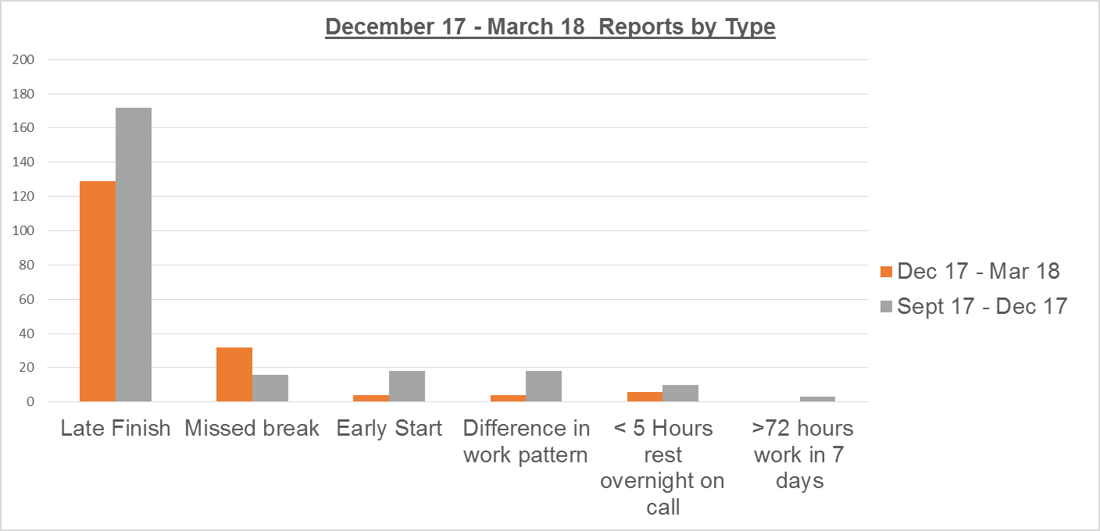
B. v. Types of exception reports analysis
The DRS system allows trainees to indicate more than one reason on a single report. This occurred in 34 reports in the December 17 – March 18 quarter. On 30 occasions this double reporting was for missed breaks in addition to a late finish. The GOS has encouraged trainees to adopt a one reason one report policy, as the appropriate outcomes for report types may be very different. As in previous quarters, late finishes continue to form the vast majority of exception reports.
The number of reported missed breaks doubled during this winter quarter, but remains low, and was the sole reason for reporting on only two occasions. Correlating reports with other sources of information, the GOS believes this still to be a significant under reporting, but is encouraged that trainees are now utilizing the system to highlight this problem.
The majority of reports arose from the cardiology (10 reports) and oncology (9 reports) departments. The GOS is analyzing work schedules for two trainees in these departments, whose reported break frequency is approaching 25% and fines may be levied as a result.
As in previous quarters the six incidences of disturbed rest during non-resident on call nights were all reported by trainees in microbiology. The department encourages reporting and has a process to provide TOIL within 24 hours. The frequency currently remains low, and the GOS is not concerned with the ongoing viability of a non-resident on call rota.
The frequency of difference in work pattern reports is low. However, trainees have been frequently contacting the GOS reporting predictable problems associated with rotating internally in the trust, and the shift clashes that they foresee. (e.g. finishing on night shifts and unable to attend induction in a new department). Trainees are experiencing difficulties promoting a dialogue between departments. The most junior grades rotate most frequently, and have the most difficulties in this area. The GOS has therefore liaised on their behalf to establish lines of communication between rota coordinators and negotiate individual solutions. This is time consuming and inefficient. A trust wide policy would be a better solution going forward to provide clarity.
Recommendation 4: The trust should devise a process for managing operational rotas for doctors around rotation times to prevent shift clashes when moving from one department to another.

DRS reporting system update

Many of the problems of the DRS system highlighted by the GOS in previous reports remain (e.g. integration with rostering systems, linking reports with work schedule reviews). However, the GOS is pleased with the progress made in the DRS reporting system this quarter due to a number of important developments:
- Password reset: Doctors using the system (juniors and supervisors) are now able to reset their own login password, which has reduced the workload for the GOS support officer and HR and improved the system for most users.
- Accept & reject outcomes: Juniors have now been provided with the facility to reject the management of a report if this has not been agreed with them at the time of closure.
The GOS has requested that the system flags these instances to the GOS directly by email, and is awaiting to hear if this is possible. This will be required for the GOS to be aware of all instances and provide support for trainees and where necessary supervisors.
- Fulfillment status: Trainees now have the ability to flag when an outcome (TOIL or Payment) has not been provided. The GOS is confident that all agreed payments are enacted, but is currently unaware if TOIL is not provided.The GOS has requested for all TOIL outcomes marked as unfulfilled by trainees be highlighted to her automatically by the system, this will be required to provide proper oversight.

In the previous report the GOS recommended: The the board to explore the costs and potential advantages of the alternative exception reporting system (Allocate) The GOS has not received an update from the trust (recommendation 3)

Since implementation of the new T&CS commenced in October 2016, there have been ongoing difficulties in obtaining details of all trainees’ supervisors by the time of their post commencement. This is despite concerted efforts by human resources, the education centre team and the GOS. Interim arrangements are in place for educational faculty leads to initially manage reports, but are less than ideal, and do not fulfill the contractual obligation for educational supervisors to oversee reports. Currently there is no accurate central list of educational supervisors for trainees in the trust. The GOS is exploring if the new medi-rota system (being rolled out across the trust to manage operational rotas) could be modified, to enable departmental rota coordinators to input this data. This would be the most accurate and efficient way of collecting and maintaining data.
C. Work schedule reviews
i. Ongoing at end of previous quarter
Care of the elderly (COE)
Junior doctors at FY1-2 level and ST2 levels submitted a total 49 reports in three months. This amounted to 68 hours of additional work for the 9 doctors who had reported. A pattern had emerged of excessive hours. By the 21st November only 10 reports had been managed, with no remuneration offered in 8 cases. The GOS requested a work schedule review.
The department did not devise a plan to manage the situation and the work schedule was escalated to level 2.
The GOS met with the clinical lead of elderly care and POPS services together with HR in January, to review the work issues in more detail and explore solutions. The junior staffing structure of elderly care was explored. This is particularly complex, with cross cover from surgical trainees (POPS) stroke and general medicine. It was unclear from exception reporting if problems lay in POPS or elderly care trainees.
Contributing factors identified in ERs:
- Workload despite good team working is exacerbated on days when middle grade cover is inadequate
- Operational rotas not aligned with work schedules in elderly care (no issue with POPS)
- Organisation of clinics and cross site working needs reviewing
Departmental response;
- Agreed inconsistencies between operational rota and work schedule. New work schedules will be needed and operational rotas reviewed.
- COE Departmental lead declined to meet with trainees to discuss other issues raised through exception reporting.
GOS meeting with elderly care trainees:
- Problems identified in exception reporting acknowledged to be an issue on occasions
- Consultants supportive of trainees. Going home on time is encouraged, but can be unfeasible if patients’ discharged on schedule. Variable attitude of consultants to exception reporting
- Overall workload comparable to other posts and would be manageable with some suggested organizational changes, new processes and purchasing of equipment to improve efficiency.
- Trainees reiterated the importance of the intermediate care fellows to ongoing safe working and delivery of safe patient care.

Actions required by Department;
- Secure permanent funding for intermediate care fellows
- Work with HR to devise new work schedules and rotas which are aligned
- Improve clarity of trainees working areas for HR and exception reporting to accurately identify problem areas in future
- Meet regularly with their trainees to discuss and implement organizational changes to improve efficiency

Progress:
The POPS team reviewed the working patterns and areas of working of their trainees. The response of the POPS team has been positive, with strong links with trainees in their department. The working pattern of the POPS doctors is not a current cause for concern
The COE clinical lead requested (and received) support from the GOS to maintain funding for the intermediate care fellows, which the GOS understands is now secure. HR met with the consultant managing the operational rota in elderly care and devised a new work schedule. This has been declined by the department. The department has not provided information to clarify trainees working areas. The GOS can find no records of local faculty meetings in COE
Outcome:
The GOS is very concerned with the progress made with the work schedule review for (Non POPS) elderly care doctors, particularly the lack of regular meetings with trainees and a work schedule that is out of line with operational rotas and working patterns
Urology FY2 trainees
The GOS reported in the last quarter on a work schedule review that remained incomplete at the end of the quarter.
Outstanding issues were:
- Management of the rota is currently devolved to a trainee, with insufficient administrative support to manage gaps from vacancies and sickness in an appropriate and contract compliant way.
- Lack of timely distribution of an operational rota.
- Culture that did not support trainees to exception report.
The situation has improved over the last quarter;
- The assistant service manager is now providing administrative support for the rota coordination.
- Training and support will be provided for the service manager via the quarterly rota-coordinators meetings.
- A new educational lead for FY2 doctors has been appointed (Susan Willis)

Ongoing issues remain:
The GOS cannot find records of local faculty meetings and is concerned these may not have been happening. The new educational lead should remedy this within the next quarter

The GOS has now been sent the operational rota by the service manager and this is not aligned with work schedules. The service manager and new educational lead will work with HR to create new rotas and schedules suitable for trainees and the clinical service.

Progress has been made in the safe working of trainees in urology, but new issues have come to light and the work schedule review is ongoing as a new operational rota and work schedule will be required.
- New work schedule review
Cardiology core trainees
A clear pattern of unsafe working has been documented through exception reporting by core trainees in cardiology, with 24 reports submitted in the last quarter. The GOS reviewed these, and also met with a number of past and present core trainees in the department to identify problems. Contributing factors to poor conditions include;
- Consultant ward rounds unreliable in both frequency and timing
- Incompatibility between ward based and subspecialty based structure of the clinical team – needs reviewing
- Unnecessary duplication of consultant completed administrative work due to lack of consultant training
- Large workload clerking elective patients that would be suitable for other members of MDT
- Hierarchical structure of department, where trainees feel anonymous
- No effective supervision meetings: Difficulties with SLEs, and completion of placement paperwork
- Lack of participation of CMT trainees in MDT
- Some consultants not contactable in on call weeks
- No exposure to clinics (planned but cancelled to cover service)

Cardiology exception reports have not been able to be assigned to named clinical supervisors as the departmental lead has not provided the GOS with names. Reports have been left unmanaged by the faculty lead despite repeated reminders. The lack of engagement with the educational faculty lead is concerning and has been escalated by the GOS within the department and directorate.
The deputy clinical director (Miss Bell) has established a regular constructive meeting to discuss juniors’ education and working hours issues across the directorate. The GOS notes the cardiology faculty lead has not attended these meetings, which are constructively working with trainees to find solutions to problems identified. The GOS was impressed by the openness of these meetings where trainees were able to speak freely of problems encountered.

The GOS currently lacks confidence that core level juniors in cardiology are working safely or supervised effectively. The GOS is requesting assistance from the trust board to review the educational leadership structure for core trainees in cardiology.
D. Safe working of Palliative Care Trainees 18th December 2017 – 31st March 2018
Exception reports by ST3+ trainees in Palliative Care
Site | Exceptions carried over from last report | Exceptions raised 18th Dec 17 – 31st Mar 18 | Exceptions closed  18th Dec 17 – 31st Mar 18 | Exceptions outstanding
Marie Curie | 0 | 8 | 1 | 7
KCH | 0 | 5 | 5 | 0
St Christophers | 4 | 4 | 3 | 5
Pilgrim's Hospice | 1 | 0 | 1 | 0
Palliative Care | 5 | 17 | 10 | 12

Response time for reports submitted in Palliative Care this quarter
Site | Exceptions raised  18th Dec 17 – 31st Mar 18 | Closed <7 days | Closed > 7 days | Open at end of quarter
Marie Curie | 8 | 1 | 0 | 7
KCH | 5 | 5 | 0 | 0
St Christophers | 4 | 2 | 0 | 2
Pilgrim's Hospice | 0 | 0 | 0 | 0
Palliative Care | 17 | 8 | 0 | 9

Types of exceptions reported in Palliative Care
Types of Reports | Late Finish | Early Start | Missed break | Difference in work pattern | < 5 Hours rest on call | >72 hours in 7 days
Types of Reports | (% reports) |  | (% reports) |  | (% reports)
18th Dec 17 – 31st March 18 | 14 (70%) | 0 | 5 (25%) | 0 | 1 (5%) | 0
*3 reports included more than one type
Outcomes of reports in Palliative Care
Site | TOIL | Payment | No action required
Marie Curie | 1 | 0 | 0
KCH | 1 | 4 | 0
St Christophers | 2 | 0 | 0
Pilgrim's Hospice | 0 | 0 | 0
Palliative Care | 4 | 4 | 0

Types of exceptions reported in Palliative Care
Types of Reports | Late Finish | Early Start | Missed break | Difference in work pattern | < 5 Hours rest on call | >72 hours in 7 days
Types of Reports | (% reports) |  | (% reports) |  | (% reports)
18th Dec 17 – 31st March 18 | 14 (70%) | 0 | 5 (25%) | 0 | 1 (5%) | 0

Palliative Care – Lead employer status and exception reporting
Guys and St Thomas’ has been the Lead employer for specialty Palliative Care training in London.The lead provider Guardian is responsible for oversight of Palliative care trainees’ safe working. GSTT has not tendered to retain this contract, and will consequently no longer be the lead employer from 1st April 2018. This will therefore be the last time that the GOS reports on palliative care trainees separately in this report, and will hand over this responsibility to the GOS for St Helens and East Knowlsey Trust.
The GSTT Guardian has written to the Guardians of relevant hospitals requesting data of exceptions submitted by Palliative Care trainees in their institutions, to enable a comprehensive report on all Palliative care trainees working patterns to be compiled. Not all have replied by the time of this report submission, and the GOS will provide full results on this in the annual report due for submission shortly.

This report includes all exceptions reported in Palliative Care in GSTT and all training Hospices. Any trust grade doctors employed by and working in hospices have not been included.

The GOS has had regular discussions with the Palliative Care TPD, and also provided data and a presentation for the recent Palliative Care Educational supervisors training day. Individual support has been provided to supervisors and hospices targeted to their requirements and subsequent events.

Three exception reports are still outstanding from previous quarter, all from the same supervisor in St Christopher’s Hospice, who has not engaged with the GOS. These 3 reports will be closed by GOS with payment as remuneration.

Like other specialties, late finishes formed the majority of reports with a total of 22 additional hours reported.
Palliative care trainees submitted reports for missed breaks alone, which is uncommon within a trust setting.

Nearly half of all exception reports arose from the Marie Curie Hospice, which generated 75% of reports in the previous quarter. The local educational lead is trying hard to resolve the ongoing problems in the unit, and is working constructively with trainees, providing TOIL and seconding additional staff to enable this when possible as requested by trainees. However, there is clearly still a manpower deficiency and the new GOS will need to monitor this closely. The GOS will provide a comprehensive handover.

E(i) Locum Spend 18th December 2017 – 18th March 2018

Locum and Agency Spend by Department
Directorate | Agency | Bank | Grand Total
Acute Medicine | £95,674.85 | £262,398.41 | £358,073.26
Cardiovascular Services | £38,854.02 | £124,087.77 | £162,941.79
Clinical Imaging & Med Physics |  | £36,455.67 | £36,455.67
Dental Services |  | £121,073.15 | £121,073.15
Evelina Community Services |  | £2,542.26 | £2,542.26
Evelina Medicine & Neonatology | £26,187.12 | £62,563.41 | £88,750.53
Evelina Surgery & PICU |  | £35,452.25 | £35,452.25
Gastrointestinal Medicine & Surgery | £8,385.88 | £37,513.29 | £45,899.17
Medical Specialties |  | £13,925.98 | £13,925.98
Oncology & Haematology | £25,228.39 | £81,525.20 | £106,753.59
PCCP |  | £48,124.76 | £48,124.76
R&D : NIHR |  | £22,677.92 | £22,677.92
Specialist Ambulatory Services |  | £57,220.27 | £57,220.27
Surgery |  | £48,865.49 | £48,865.49
Transplant, Renal and Urology |  | £79,054.16 | £79,054.16
Womens Services | £5,544.00 | £40,747.84 | £46,291.84
Grand Total | £199,874.26 | £1,074,227.83 | £1,274,102.09

E (ii) Locum Bookings 18th December 2017 – 18th March 2018
Directorate | Agency Filled Shifts | Bank Filled Shifts | Grand Total | % Bank vs Agency
Acute Medicine | 191 | 451 | 642 | 70%
Cardiovascular Services | 98 | 236 | 334 | 71%
Clinical Imaging & Med Physics |  | 54 | 54 | 100%
Dental Services |  | 322 | 322 | 100%
Evelina Community Services |  | 6 | 6 | 100%
Evelina Medicine & Neonatology | 55 | 144 | 199 | 72%
Evelina Surgery & PICU |  | 52 | 52 | 100%
Gastrointestinal Medicine & Surgery | 15 | 70 | 85 | 82%
Medical Specialties |  | 35 | 35 | 100%
Oncology & Haematology | 71 | 172 | 243 | 71%
PCCP |  | 81 | 81 | 100%
R&D : NIHR |  | 69 | 69 | 100%
Specialist Ambulatory Services |  | 150 | 150 | 100%
Surgery |  | 106 | 106 | 100%
Transplant, Renal and Urology |  | 148 | 148 | 100%
Womens Services | 7 | 102 | 109 | 94%
Grand Total | 437 | 2198 | 2635 | 83%

E (iii) Locum bookings by Grade 18th December 2017 – 18th March 2018

Grade | Agency Filled Shifts | Bank Filled Shifts | Total Filled Shifts
FY1 |  | 11 | 11
FY2 | 184 | 134 | 318
ST 1 / 2 | 42 | 413 | 455
ST2 Spec Rate |  | 62 | 62
ST 3 / 4 | 211 | 1243 | 1454
ST4 Special Rates |  | 335 | 335
Grand Total | 437 | 2198 | 2635

E (iv) Locum bookings by Reason 18th December 2017 – 18th March 2018

Reason for Request | Agency Filled Shifts | Bank Filled Shifts | Total Filled Shifts | % Shifts
Activity | 53 | 688 | 741 | 28%
Vacancy | 70 | 543 | 613 | 23%
Research / Projects | 216 | 782 | 998 | 38%
Leave | 98 | 178 | 276 | 10%
Sickness |  | 7 | 7 | 0%
Grand Total | 437 | 2198 | 2635 | 100%

Locum bookings

Total agency and Staff Bank spends have been stable over the last three quarters. Higher spends are seen in acute medicine, which is not unexpected with winter pressures. This has been offset by a reduction in oncology spend. Whilst this is concerning (given the number of exception reports in oncology) the GOS has no vacancy data to set against these departmental spending changes requirement.

The data documents the overall number of shifts was static. The proportion of locum bookings filled by the staff bank also remained stable at 83-84%. Similarly there is no significant change in the breakdown of bank shifts by grade this quarter

The GOS has included data collected by staff locum bank on the reason for shifts being booked, there is no change in this data from the last report. However, the GOS, staff bank and human resources do not consider this data currently to accurately reflect the real underlying reason for the shift request.
The GOS plans to triangulate trainee vacancy data with locum shift requests once reliable data is available for both datasets.

F. i. Locum work carried out by junior doctors who also exception reported

Department | Grade | Work schedule hrs | ER hours:  Paid,  no action, or open | Rota Cycle | Average contracted & reported hours per week  (max 48) | Total Bank hours:  13 weeks | Bank hours average per week | Average hours per week total (max 56)
O&G | ST3+ | 47.25 | 2 | 12 | 47.42 | 4 | 0.31 | 47.72
Acute Med | Core | 40 | 2 | 4 | 40.50 | 49.5 | 3.81 | 44.31
Infection | ST3+ | 45 | 5 | 17 | 45.29 | 400 | 30.77 | 76.06
O&G | Core | 47 | 2 | 12 | 47.17 | 35 | 2.69 | 49.86
Spec Med | FY1 | 47.5 | 5 | 14 | 47.86 | 12 | 0.92 | 48.78

F. ii. Locum work carried out by junior doctors not exception reporting

(Limited to trainees working >104 Bank shift hours in 13 weeks)

Department | Grade | Total Bank hours | ATC hrs/week (Ave) | Work schedule hrs/week | Total hrs/week (Ave) | Opted out WTR | Total Hours per week  (working through all annual leave)
Interventional Radiology | ST3+ | 316 | 24.31 | 44.75 | 69 | Y | 64
Radiology | ST3+ | 224 | 17.23 | 46.25 | 63 | Y | 59
GI Surgery | Core | 146 | 11.21 | 47.5 | 59 | Y | 54
GI Surgery | ST3+ | 145 | 11.13 | 47.5 | 59 | Y | 54
ICU | ST1-2 | 129 | 9.88 | 47 | 57 | Y | 52
Anaesthetics | Core | 125 | 9.62 | 47 | 57 | Y | 52
Paediatric Specialty | ST3+ | 119 | 9.13 | 47 | 56 | Y | 52
Oncology | ST3+ | 116 | 8.92 | 40 | 49 | Y | 44
Paediatric Surgery | ST3+ | 113 | 8.69 | 44.25 | 53 | Y | 48

.

Analysis of working patterns of junior staff working additional shifts through staff bank.

The GOS has received confirmation that all trainees working through staff bank have opted out of the working time regulations, and are therefore able to undertake additional work to a total of 56 hours per week on average.

The list of all 396 trainees undertaking any staff bank work was cross referenced with the exception reporting database, and five trainees were found to have exception reports for additional hours. None of these trainees exceeded 48 hours per week on average due to exception reporting, and four worked less than 56 hours per week after staff bank work was also included.

One trainee (infection department) worked 400 hours for the staff bank in 13 weeks ( >30 hours per week), and therefore exceeded 56 hours per week limit. This trainee would have exceeded this threshold without exception reporting for the additional 5 hours, and even if they had utilized all of their annual leave for staff bank work.

The GOS then reviewed all juniors who undertook more than 104 hours of bank work in the quarter. Average bank working per week was calculated for the 13 week period and added to the work scheduled hours. Seven trainees have worked more than 56 hours/week on average over the quarter by this calculation. It is possible that 5 of these trainees may still have actually worked less than 56 hours per week during this period, by utilizing annual leave. However, two trainees (both ST3+ in radiology) have certainly breached the 56 hour average limit working.

Previous quarterly report included a trainee in Radiology who breached the 56 hours per week limit through bank work, and it is notable that two of the three trainees certainly breaching 56 hours per week this quarter also come from that department. No trainees working in excess of 56 hours per week appeared in two successive quarters

The GOS recognizes that this is an analysis of work over an entire quarter, rather than tailored to the individual rota cycles of each trainee. However, whilst there is no automation of this process, or linking of the HR, exception reporting and staff bank systems, the GOS does not currently have the capacity to undertake a more detailed assessment.

The GOS will write to relevant departments and trainees reminding them of their joint responsibility to work within the 56 hour limit, and advising how much work can be undertaken safely within a 3 month period.

The GOS advised in the last report that staff bank should limit bank hours for junior doctors (who have a trust contract for regular work) to a maximum of 104 hours of staff bank work per quarter. This would largely limit contracted and staff bank hours to within the 56hours/week and prevent significant excess and unsafe working due to locum shifts. The GOS considers that this action would fulfill the trusts share of the joint responsibility to ensure this 56 hours per week limit is adhered to.

The trust has not implemented this recommendation, and the GOS has not been informed of any other processes put in place by the trust to prevent individual trainees undertaking very significant additional workloads seen this quarter.

As documented in the previous report, the trust has no mechanism for monitoring or assessing the safety of locum work carried out by GSTT doctors in training for other NHS organisations (e.g. other trust staff banks). The GOS does not envisage that this is technically possible outside of a national database held and managed by HEE, for which there are currently no plans.

Summary:
- 396 junior doctors have undertaken additional work through the trust locum bank in this period. The GOS has determined that 388 done so within the safe working rules and have opted out of the WTR.
- 8 trainees have worked in excess of 56 hours per week on average, of which 3 have breached this limit even if using all their annual leave entitlement during the period to work for staff bank.
- One trainee has worked in excess of 70 hours per week on average, which is a concern for patient safety.
- The GOS acknowledges the joint responsibility for trainees and the trust in this, and urges the trust to put a system in place to prevent this in future.

Recommendation 5:

The GOS again advises the staff bank to limit trainees who have a contract for regular work to a maximum of 104 hours of work per quarter, or devise an alternative process to limit contracted and staff bank hours to within the 56hours/week limit and prevent significant excess and unsafe working.
G. Vacancies

As outlined in the previous GOS report, the trust currently has no mechanism for reporting vacancies on junior doctors’ rotas. With the expansion of the 2016 contract to all specialties, it has not been possible for the GOS to collate comprehensive data trust wide manually.

The GOS met with rota-coordinators from a number of departments implementing the electronic “medirota” system, to ascertain if this could provide a solution for identifying post vacancies and individual shift gaps trustwide. The system shows promise but would need additional features added to enable central correlation of data.
The GOS has arranged to meet with the system designers to explore this capability.

Vacancy numbers for HEE trainees
Month | Trainees rotating | Vacancies | Departmental vacancies
December | 160 | 0
January | 17 | 0
February | 130 | 10 | Anaesthesia (8) ICU (1) Emergency Med (1)
March | 128 | 5 | Oncology (1) Radiology (2) Paediatrics (2)

No correlation has been found between training post vacancies and exception reporting rates in December, January or February. The vacancy in oncology is noted for March but reporting rates are consistent in this department. This lack of correlation is almost certainly due to the large number of trust doctors the trust employs at all levels and in most departments.
- Fines
Department | Reason | Value of fines levied
Palliative Care | Missed break  48 hour average | £910.15
Cardiology | 48 hour average | £96.24
Vascular | 72 hour rule | £621.71
Urology | 72 hour rule | £87.80
Total |  | £1,715.50

Fines income to GOS administered fund (cumulative) - –
Cost code 648040
Balance at end of last quarter | Fines this quarter | Disbursements this quarter | Balance at end of this quarter
£931.70 | £1715.5 | £0.00 | £2646.97

The previous report contained finance information that the GOS extrapolated from hours of fines levied.
The GOS requested this information to be confirmed by finance and HR during this quarter. The GOS has been informed that fines have been levied however, some fines have yet to be paid into the GOS account. (Trainees have received payment). This was due to staffing turnover and shortages in HR.
This has created a discrepancy between the closing balance last quarter and the opening balance this quarter.
The GOS has requested that all fines levied be paid into the account with immediate effect. Representatives from finance and HR are resolving this matter urgently.
The GOS will monitor closely and provide a full update in the annual report due within the next 4 weeks.
No payments from this fund have yet been made.

I. Contract Breeches
The GOS attended the junior doctors trust induction in February 2018.
Of the 130 doctors rotating, 19 reported not having received a work schedule by the time of induction.
The GOS provided HR with doctors contact details and requested an investigation, which revealed;
- 14 (74%) trainees had been sent the correct work schedule but had not remembered or reviewed it.
- 3 (15%) trainees had not received the correct work schedule due to errors from HEE;
  - 1 (5%) was not on grid from HEE and trust were unaware they were starting.
  - 2 (10%) had received work schedules but for the wrong post due to HEE errors on grid
- 1 (5%) doctor should not receive a work schedule as they are an honorary appointment only
- 1 (5%) doctor was appointed too recently to have received a work schedule (late trust interview to backfill a gap)

There is obviously still scope to educate trainees on the importance of their work schedule, and ensure that they review it, and exception report against it. It is notable that errors by HEE accounted for all of the contract breeches seen during this induction.
The trust has been informed that NHSI intend to monitor the trusts (non contractual) provision of operational rotas to trainees 6 weeks prior to post commencement in all its departments To facilitate this reporting of rota provision to NHSI, the ability to provide this data should be a requirement of any rostering system the trust implements.
In the last quarter the GOS recommended this should be included when assessing an electronic rostering system purchased by the trust. The GOS investigated the ability of medi-rota to provide this data with current trust users.
A rota provision log is held by the system, however, it is not currently exportable in a usable format to correlate data across the trust. The GOS is meeting with the system manufacturers to explore this issue further.

J. Junior Doctors Forum and Qualitative information
The GOS chaired the quarterly Junior Doctors Forum on 26th March.
Despite considerable work by the GOS project support officer, representation from trainees was again disappointingly small but significantly improved from the previous meeting with 9 departments represented.
Concerns raised directly by trainees in the forum have been explored personally by the GOS, by undertaking departmental visits and discussions with relevant clinical leads and managers and focus groups of trainees and have been included elsewhere in this report.
The meeting discussed ideas for the disbursement of fines which the GOS will take forward. These included;
- Meeting to educate trainees in completion of tax return and provide important payslip information (LNC have offered to work with HR on this project)
- Support junior trainees to attend conferences to present their work (A limited number of individual grants for £100)
- Catering for educational events and the forum
- Equipment and environmental improvements above those listed as essential
The GOS has agreed to work with a junior doctor to survey trainees across the trust determine the cause of poor attendance and identify changes that would improve engagement as well as gather views on fines utilization.
The GOS plans to schedule future forums to be after quarterly report submission to enable discussion of items highlighted in the report

K. Update on recommendations from previous report;
- The GOS advises the board to explore the costs and potential advantages of the alternative exception reporting
system (Allocate) - No update received

- The GOS now proposes that the current exception reporting process in the trust is robust enough to implement the contractual time limits for exception reporting (14 days maximum and 7 days if payment is to be provided) except in exceptional circumstances. – Implemented by HR
- The new oncology directorate lead has been a significant and positive factor in the improvements seen in oncology in the last quarter. Ongoing support from the medical director and trust board are advised to implement the further improvements necessary in junior doctors working. Ongoing
- The trust should actively discourage departmental clinical and educational lead posts being held by the same person in departments. There is often a tension between these roles. Supporting trainees whilst undertaking both roles is an unnecessary challenge. No update received. Leads in oncology and care of the elderly still holding both posts
- The GOS advises the staff bank to limit trainees who have a contract for regular work to a maximum of 104 hours of work per quarter unless annual leave is used. This would limit contracted and staff bank hours to within the 56hours/week limit and prevent significant excess and unsafe working.- Not Implemented (see above ongoing concerns)
- The ability to provide monitoring data for rota publication rates 6 weeks in advance of placements should be a requirement for any electronic rostering system purchased by the trust. Explored by GOS ongoing
- The GOS asks the trust to provide a link from the front page of the Gti to the Guardian of Safe working website, to improve trainee and supervisor access to the website resource.- Implemented with trust support by GOS

