GUY’S AND ST. THOMAS’ NHS FOUNDATION TRUST 18thJune – 16th September 2018
QUARTERLY REPORT ON SAFE WORKING HOURS - DOCTORS AND DENTISTS IN TRAINING:

Executive summary
Exception reporting provides an overall picture of the working patterns of 1054 trust doctors and trainees working at GSTT. Exception submissions have almost doubled from 110 reports in the previous quarter to 208 in the current period. This is significantly higher than rates in the same period last year (162 reports). On average one report is submitted each quarter for every 4 trainees and every 9 trust doctors (section Bi).
The increase in this quarter was in a large part due reporting by Foundation and core trainees in oncology, who account for 35% of all reports submitted (73 reports). The GOSW believes this to still be an under estimation of additional working by these trainees. Physician associates have not been appointed in this quarter, and the department has recruited additional locum doctors from October to assist with workload. Other operational changes have been implemented but have failed to prevent significant excess working. The GOSW considers more fundamental organizational changes are warranted to enable appropriate working patterns to be embedded. The work schedule review has not been closed.
The GOSW considers that Foundation and Core trainees in oncology are working unsafely and intervention by the trust to assist the department is required
The GOS believes that the situation in oncology has (in part) resulted from the rapid expansion or re-organization of a service without due consideration of the work force implications for junior medical staff and recommends the trust consider this issue more widely in future.
Correlation of exception reporting with the GMC trainee survey has been attempted. Whilst some departments are clearly flagged in both sets of data (Oncology) others with a red flag for workload have no exception reporting data (Occupational Health). Some specialties with exception reporting are green flagged in the survey (Palliative Care). Clearly the survey and exception reporting reflect culture and morale as well as experience. Reporting can be seen as positive as well as negative, and pure numbers are of little value without understanding the underlying issues and cultures involved.
Senior trainees continue to be much less likely to report. However, there is a trend to increased reporting at registrar levels (increased from 8% to 21%) which is reflected regionally as trainees advance grades.(section Biv).

All reports carried over from the previous quarter have been closed.
81% of all reports submitted in this quarter have been closed, although only 32% have been managed within the contractual requirement of 7 days, compared to 50% in the previous quarter. Time to closure is similar for all grades of doctor. (section Bv).

There was a significant increase in the percentage of reports closed with payment in this quarter (69% vs 50%) driven mainly by the inability to offer TOIL to oncology trainees. (section Bvi).
In line with previous quarters, late finishes continue to be cited in the vast majority (92%) of exception reports..There was a continuation of the previous trend for missed breaks to be increasingly reported (39% of reports) up. This was a particular problem in oncology where 44 missed breaks reported and 2 fines levied as a result. Other types of report are infrequent.
New locum bank rates were implemented on the 11th August, which were agreed with other trusts in the region and applied Pan London. Total agency and Staff Bank spends and bookings have been relatively stable, rising £125K this quarter on an overall spend of £1.3M. Locum spend in oncology rose by only £30K, funding an additional 84 shifts in this quarter (section Dii).

309 junior doctors have undertaken additional work through the trust locum bank in this period. 305 have done so within the safe working limit of 56 hours per week (averaged over the quarter) and have opted out of the WTR. Four doctors worked in excess of 56 hours per week on average in the quarter. A new process to identify doctors at risk requires the support of Allocate to implement and is hampered by the retrospective booking of the majority of shifts (Section E)

The total vacancy rate for junior doctors across the trust is currently unknown. HEE data reports a small number of vacancies in this period that do not correlate with exception reporting data. Discussions with Rota Map are ongoing to deliver data for all junior doctors trust wide. (section F).

A further ten fines have been levied in this quarter, increasing the GOS fines income by a further £1247.22. Half of all fines were levied in Oncology. £9400 of fines levied to date have been spent in this quarter, mainly by reimbursing 49 doctors for expenses occurred presenting their work or undertaking modules of additional learning. A plan has been drafted to ring fence funds for the benefit of vascular and oncology trainees by improving their working environment.

Around 95% of doctors starting in the trust in August received their correct work schedules and operational rotas in a timely manner. GPVTS trainees were the group most likely to receive the wrong work schedule. GSTT is working with St Georges as lead provider to resolve recurrent issues (section H)

As a result of the survey conducted regarding the Junior doctors forum, the meeting has been moved to Tuesday afternoons and will be co-chaired in future with a trainee. (section I)
Progress with implementation of recommendations from previous reports are generally on target (section J)
Recommendations;

- The GOS recommends the trust senior management team work with the oncology leads and junior doctors to review the organizational structure of care delivery in oncology
- The trust should provide funds to the oncology department to extend the period of additional junior doctor posts. This should aim to continue until physicians’ associates are appointed, trained, and able to have tasks reallocated from the current junior doctor workforce in the department and/or until organizational changes have had a significant impact on junior doctor working
- The GOS asks the trust to review the business support offered for new appointments, and in change management in the oncology department and other areas of priority need
- The GOS recommends that the junior doctor experience group prioritises improvements to the environment of trainees in oncology (at all levels) as a matter of urgency.
- The GOS recommends funds from the fines account should be specifically ring fenced to improve the working conditions of oncology trainees in the short term
- The GOS recommends the trust develop a robust process for ensuring the evaluation of junior doctor workforce implications of service reorganisations and expansions in all areas, to ensure these are appropriately and realistically identified prospectively

Structure of Report
This report utilises data from exception reporting and human resources and staff locum bank, direct contact made to the Guardian of Safe Working (from departments, supervisors, trainees and the education centre), focus groups with trainees, and the Junior Doctors Forum.

Content
A. High level data
B. Hour monitoring information - Exception reports Instances of trainees working in GSTT
- Report frequency by contract
- Report frequency by department
- Exception reports correlated with GMC trainee survey results for workload
- Report frequency by grade
- Response times for managing reports
- Outcomes for reports
- Types of reports
C. Work Schedule reviews – Patterns of unsafe working in junior doctors within the trust
- Oncology
D. Locum bookings – Shift and spend data for staff bank and agency for departments
E. Locum work – Safety assessment of additional locum work undertaken by individual trainees
F. Vacancies
G. Fines – levied by GOS under the 2016 T&CS
H. Contract Breaches
I. Junior Doctors Forum
J. Update on recommendations from previous report
Appendix A - New Pan London Staff bank rates
A. High level data provided by Medical Workforce:
Number junior doctors: 1074
Number doctors able to exception report: 1054
Number of doctors & dentists in training 2016 TCS: 733

Grade | Trainee numbers
FY1 | 60
FY2 | 76
CMT | 34
CST | 16
CAT | 13
ACCS | 20
ST3+ | 514
Total Trainees | 733

Number of trust grade doctors able to exception report: 321
Number of trust grade doctors unable to exception report: 20
Job planned time for guardian to do the role: 4Pas
Admin support provided to the guardian: 0.6 WTE Band 5 (Commenced Jan 2017)
Job-planned time for educational supervisors: 0.25 PAs per trainee (agreed).
B. Hour monitoring information
i. Exception reports 18th June – 16th September 2018 by contract
Contract | Doctors | Reports  June - Sept 2018 | Reporting rate  June - Sept 2018
Trainee | 733 | 172 | 1 per 4 doctors
Trust | 321 | 36 | 1 per 9 doctors

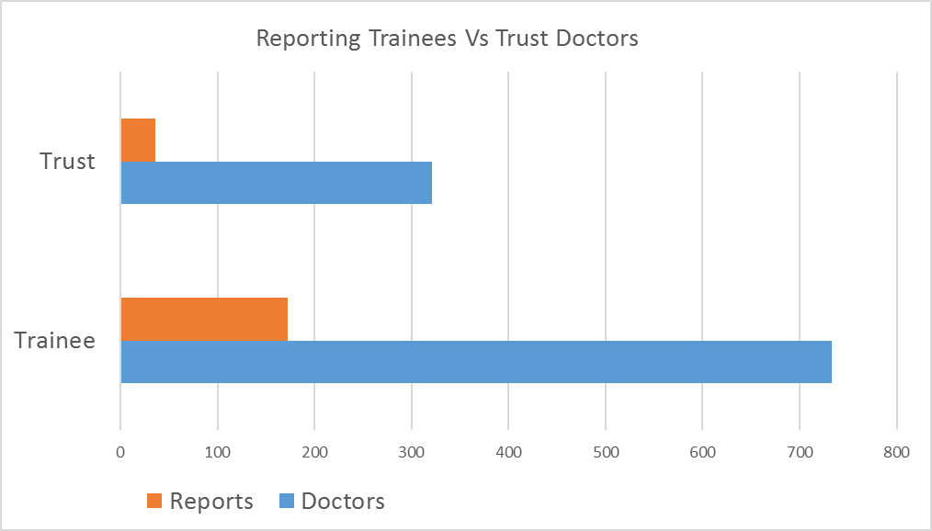

- Exception reports 18th June – 16th September 2018 by department (data table)

Specialty | Exceptions carried over from last report | Exceptions raised June - Sept 2018 | Exceptions closed | Exceptions outstanding
Accident & Emergency | 0 | 4 | 2 | 2
Acute Medicine | 2 | 3 | 5 | 0
Cardiology | 1 | 3 | 4 | 0
Elderly Care | 0 | 5 | 5 | 0
ENT Surgery | 0 | 2 | 0 | 2
Gen Medicine | 0 | 37 | 29 | 8
H@N | 0 | 1 | 1 | 0
Haem/Oncology | 6 | 73 | 68 | 11
Infection | 0 | 10 | 10 | 0
Nephrology | 1 | 1 | 2 | 0
O&G | 0 | 10 | 6 | 4
Specialty | Exceptions carried over from last report | Exceptions raised June - Sept 2018 | Exceptions closed | Exceptions outstanding
Orthopaedics | 0 | 1 | 1 | 0
Paed ED | 1 | 7 | 7 | 1
Paed Neurology | 0 | 1 | 0 | 1
Paed Resp | 0 | 14 | 13 | 1
Psychiatry | 0 | 5 | 5 | 0
Palliative | 0 | 7 | 7 | 0
Surgery GI | 1 | 18 | 10 | 9
Vascular surgery | 4 | 6 | 10 | 0
Total | 16 | 208 | 185 | 39

- Exception reports 18th June – 16th September 2018 by department (graphically)
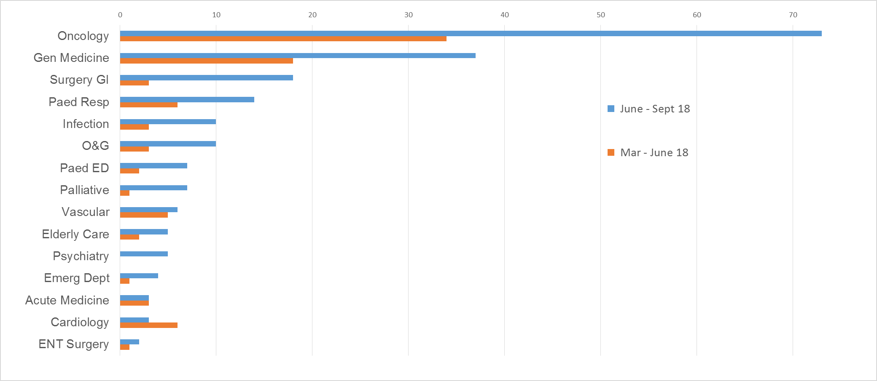
Departments with ≤1 report not shown
- Exception reports correlated with GMC trainee survey results for “Workload” by Post

Post Specialty | 2018 GMC Trainee survey "workload" | Exception reports  June – Sept
Medical oncology | 18.13 | 70
Clinical oncology | 54.46 | 70
General surgery | 30.56 | 18
Paediatric Emergency Medicine | 27.50 | 7
Vascular surgery | 19.45 | 6
Anaesthetics | 40.81 | 0
Occupational medicine | 66.67 | 0
Post Specialty | 2018 GMC Trainee survey "workload" | Exception reports  June – Sept
Palliative medicine | 56.94 | 7
Allergy | 72.92 | 0
Genito-urinary medicine | 65.05 | 0
Neurology | 71.67 | 0

Post Specialty | 2018 GMC Trainee survey "workload" | Exception reports  June - Sept
General Medicine | 37.07 | 37
Medical microbiology | 58.33 | 10
Obstetrics and gynaecology | 38.91 | 10
Geriatric medicine | 45.54 | 5
Emergency Medicine | 29.65 | 4
Acute Internal Medicine | 51.56 | 3
Cardiology | 35.83 | 3
Haematology | 48.56 | 3
Otolaryngology | 36.25 | 2
Paediatric Neurology | 44.45 | 1
Renal medicine | 34.62 | 1
Trauma and orthopaedics | 42.06 | 1
Departments with average workload results in trainee survey and no exception reports not shown

Rate of exception reporting over the quarter discussion:

The number of exception reports increased significantly in this period from 110 in the previous three months to 208 in this quarter.

The incidence of reporting by trainees approximately doubled to one report for every 4 trainees (from 1:8). The increase in reporting by trust doctors was even more marked and quadrupled (from 1:37). However, with one report submitted for every 9 trust doctors, they remain considerable less likely than trainees to submit reports. The reason remains unclear.

Reporting rates have previously been highest in August and September (after the major changeovers of trainees) particularly for FY1 doctors who are working clinically for the first time. Rates have been lowest just before rotation dates, which results in exaggerated differences between the 1st and 2nd quarters in each year. That being said, the number of reports in this quarter exceeded those submitted in the same period in 2017 (162 reports).

The increase in this quarter was in a large part due Foundation and core trainees in oncology, who accounted for 35% of all reports submitted in the trust (73 reports). The GOSW has conducted a number of focus group visits to the oncology department, before and after the changeover in August, and confirmed that the above data still represents a significant under estimation of additional working hours in the department, which is a serious concern. The Guardian considers the working hours of Foundation and Core trainees in oncology to be unsafe. A work schedule review is ongoing. Further discussion of the working hours issues in the oncology department in section C.

General Medicine continues significant reporting, but in line with the large number of trainees with a GIM work schedule.

Correlation with GMC trainee survey results for workload This has been attempted, but has proven to be complex and inexact with current datasets and reporting patterns. The GOSW has discussed this with GMC representatives, to develop datasets and methodology in this area. GMC trainee data is available by programme, or by post, but not by both.

Foundation and Core trainees rotate through different departments each year. It is therefore not possible to compare program based survey data, with departmental exception reporting. Hence the use of Post based data for this report.

In many departments, core and foundation trainees make up only a small proportion of the junior doctor workforce. Workload issues for these trainees may not be reflected in GMC survey results, which reflect the whole junior doctor cohort in a department.

Likewise, some departments with rotations staffed predominantly or entirely by trust doctors and will not be represented in the survey (e.g. paediatric respiratory medicine). Although a very small department (with only 2 junior doctors) there have been a significant number of reports submitted in paediatric respiratory medicine in this quarter. All have been closed with payment, due to the inability to provide TOIL with workload pressures. The GOSW has discussed this with the educational supervisor and a work schedule review is imminent.

Of the 6 departments flagged has having workload issues in the survey no exception reports have been received in 2 (Anaesthesia) and one of whom have never had an exception report submitted (Occupational Health).

Of the remaining 4 departments;
- Vascular surgery previously had a significant problem for registrar level trainees in the last year and this is the likely cause of the red flag. An HR administration error prevented these trainees submitting exception reports at the time. A work schedule review was undertaken; additional posts funded and appointed to, and rotas revised. Fines were incurred. Current reporting levels by registrars in vascular surgery is low. Reporting by FY doctors is steady, but workloads are supporting TOIL as remuneration when agreed and no patterns have emerged.
- General Surgery Reporting has fluctuated over the previous year. The reporting rate of FY doctors was particularly high in August. Reports did not detail any particular recurring precipitants or patterns, other than a perceived large patient workload. The GOSW confirmed with the department that there were no post vacancies. It is notable that the rate settled in September, but is an area for continued observation.
- Paediatric Emergency Medicine; Paediatric Emergency Medicine has not previously been an area of concern with only 1 report submitted in the previous 6 months. However, reporting has increased to 7 in this quarter, all related to late twilight shift finishes. The GOSW is working with the department to review the underlying issues.
- Oncology The consistently high reporting rate in oncology is reflected in the GMC survey results for workload in medical (but not clinical) oncology. (see section C)

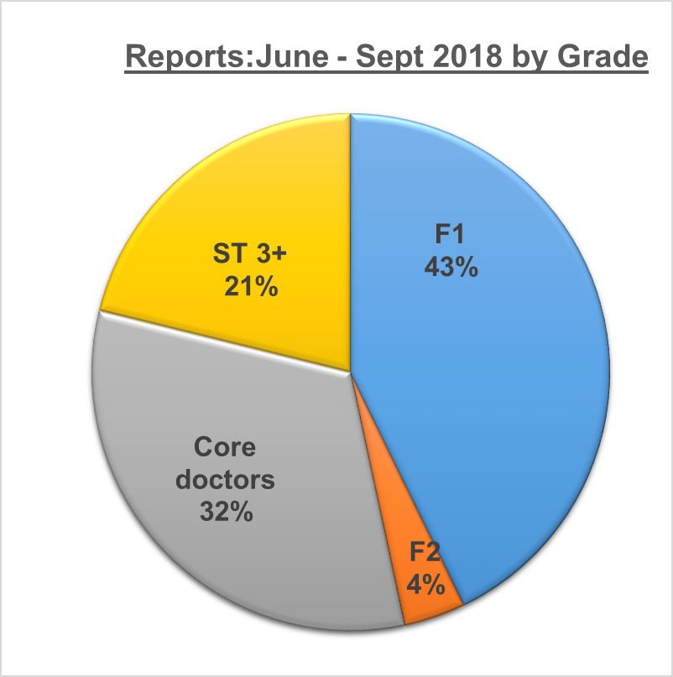
- Exception reports 18th June – 16th September 2018 by Grade
Grade | Exceptions carried over from last report | Exceptions raised June - Sept 2018 | Exceptions closed | Exceptions outstanding
F1 | 5 | 89 | 80 | 14
F2 | 6 | 8 | 13 | 1
Core Level | 4 | 67 | 53 | 18
ST3+ | 1 | 44 | 39 | 6
Total | 16 | 208 | 185 | 39

Exception reporting by Grade
There has been in increase in exception reporting by registrar grades in this quarter up from 8% to 21% of all reports. This was largely due to increased reporting in Paediatric respiratory and Paediatric Emergency Medicine. Discussions with other Guardians have revealed that this pattern is reflected across the region, as junior doctors who have made use of the exception reporting process at Foundation and core levels enter specialty training and continue to report, in contrast to their senior colleagues.
- Exception reports 18th June – 16th September 2018: Time to Closure Total

 | Total exceptions submitted | Closed <7 days | Closed > 7 days | Open
Mar 19 - June 17 | 208 | 66 (32%) | 103 (50%) | 36 (19%)

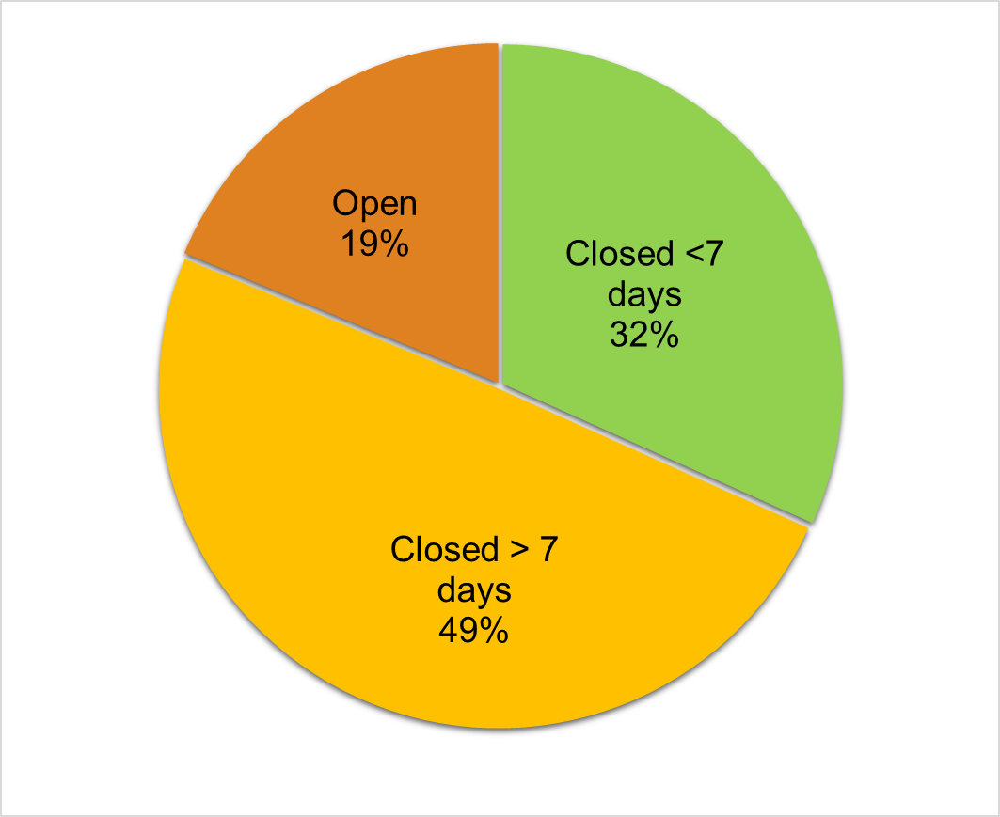

The 2016 T&CS requires exception reports to be closed within a 7 days window
Exception reports 19th March to 17th June 2018 – Time to Closure by Grade
 | Total Reports | Closed <48 hrs | Closed 48 hrs - 7 days | Closed >7 days | Open
F1 | 89 | 14 (16%) | 16 (18%) | 45 (50%) | 14 (16%)
F2 | 8 | 0 (0%) | 3 (38%) | 4 (50%) | 1 (12%)
Core | 67 | 0 (0%) | 6 (9%) | 43 (64%) | 18 (27%)
ST 3+ | 44 | 19 (43%) | 8 (18%) | 11 (25%) | 6 (14%)
Total | 208 | 33 (16%) | 33 (16%) | 103 (49%) | 39 (19%)

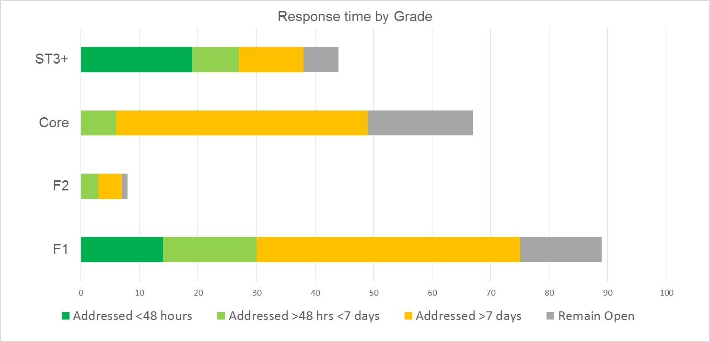
- Exception reports 18th June – 16th September 2018 Outcomes of closed reports
Report Outcomes | Payment | TOIL | No action required
June – Sept 17 | 54% | 34% | 12%
Sept – Dec 17 | 63% | 25% | 12%
Dec 17 - Mar 18 | 63% | 31% | 6%
Mar - June 18 | 50% | 42% | 8%
June – Sept 18 | 128 (69%) | 53 (29%) | 4 (2%)

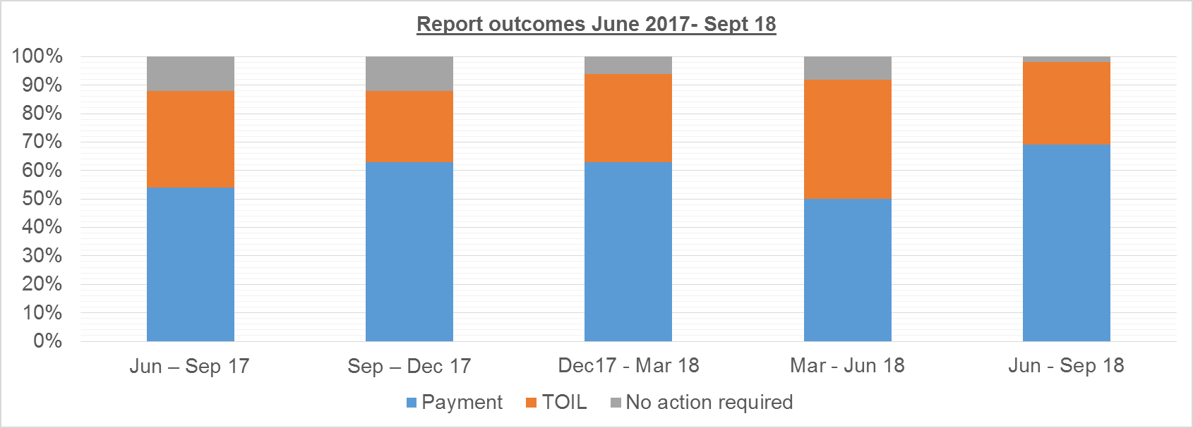
Exception reports 18th June – 16th September 2018 Outcomes of closed reports by department

Specialty | Payment | TOIL | No action
Haem/Oncology | 66 | 0 | 2
Gen Medicine | 12 | 16 | 1
Surgery GI | 7 | 2 | 1
Paed Respiratory | 13 | 0 | 0
Infection | 0 | 10 | 0
O&G | 2 | 4 | 0
Paed ED | 4 | 3 | 0
Palliative | 0 | 7 | 0
Vascular surgery | 5 | 5 | 0
Specialty | Payment | TOIL | No action
Elderly Care | 5 | 0 | 0
Psychiatry | 5 | 0 | 0
Accident & Emergency | 1 | 1 | 0
Acute Medicine | 1 | 4 | 0
Cardiology | 4 | 0 | 0
H@N | 1 | 0 | 0
Nephrology | 2 | 0 | 0
Orthopaedics | 0 | 1 | 0
Total | 128 | 53 | 4

Exception report closure analysis
All reports submitted in the previous quarter have been closed.
36 (19%) reports submitted this quarter remain open. This is comparable to the previous quarter in percentage terms.
Fewer reports were closed within the contract requirement period of 7 days (32% compared to 50% in the previous quarter) although this increase in the number of reports is likely to be the underlying driver as well as the effect of annual leave of juniors and supervisors over the summer period. Time to closure is similar for all grades of doctor

There was a significant increase in the percentage of reports closed with payment in this quarter (69% from 50%).
In previous quarters, this has been the result of non-closure of reports by the departmental supervisors when trainees rotate, and the consequent need for the GOS to close reports, with payment.
The pattern is very different in this quarter, with the GOS closing only 22 reports, and the majority of payment outcomes decided by local supervisors. Half of all reports closed with payment were again in oncology, where service requirements and staffing levels would not support TOIL being taken without resulting in further exceptions. The situation was similar, but on a smaller scale in Paediatric respiratory medicine.
Other departments are able to provide TOIL on appropriate occasions, when agreed with trainees an managed in a timely way.

- Exception reports 18th June – 16th September 2018 by type
Report Type | Late Finish | Missed Break | Early Start | Difference in work pattern | >72 hours work in 7 days | <5 Hours rest on call
June - Sept 2018 | 191 (92%) | 81 (39%) | 5 (2%) | 3 (1%) | 3 (1%) | 6 (3%)

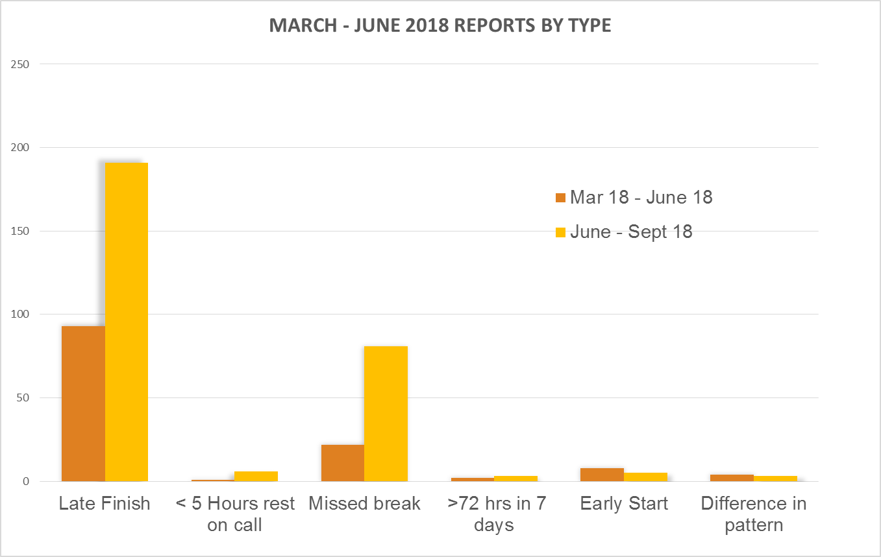
Types of exception reports analysis
The DRS system allows trainees to indicate more than one reason on a single report. This occurred in 77 reports in the June - September quarter.
The breakdown shows that late finishes continue to be cited in the vast majority (92%) of exception reports.
The data also shows a continuation of the previous trend for missed breaks to be increasingly reported, and were included in 39% of reports up from 14% in the previous quarter. This was a particular problem in oncology, where there were 44 missed breaks reported. This resulted in fines being levied for missed breaks for two trainees, one of whom had reports validated for missing 50% of their breaks in August.
Early starts were uncommon (5 reports) 3 of which again originated in oncology
As in previous quarters the incidences of disturbed rest during non-resident on call nights were mostly reported by trainees in microbiology, with one report from orthopedics. TOIL was provided in all instances. The frequency currently remains low enough for all non-resident rotas that the GOS has no concerns in this regard.
The frequency of difference in work pattern reports remains very low.

DRS reporting system update

There has been no substantial changes to the exception reporting system in the last quarter

C. Work schedule reviews
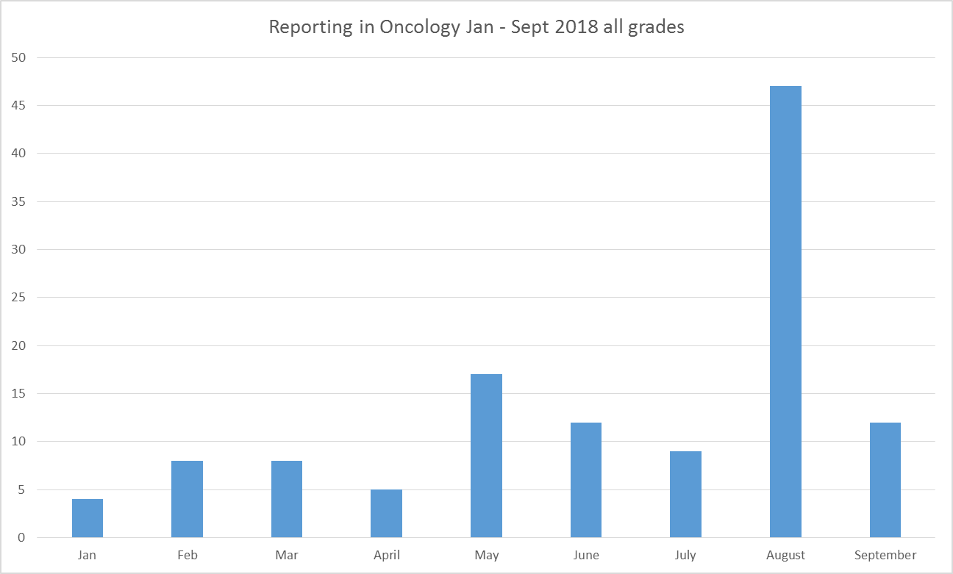
i. Oncology Foundation and Core Trainees

Grade | Oncology reports  June - Sept 17
FY1 | 25
Core | 45
ST3 | 0
Total | 70

The Clinical director met with all oncology trainees after the August changeover, and encouraged exception reporting. Subsequently FY1 and CMT trainees in oncology submitted 70 reports, 68 of which pertained to late finishes, 44 to missed breaks, 3 to early starts and 1 to working more than 72 hours in 7 days. This amounted to 128.5 hours of additional hours work. 62 reports have been closed 60 of which have been remunerated with payment. TOIL was not provided for any reports
No reports have been received from oncology registrars. Informal feedback has been that workload and hours are also an issue for this group of trainees. However, they are unwilling to report formally due to concerns about influencing their careers in the specialty.
The GOSW has met with oncology trainees at different levels on a number of occasions, and also communicated regularly with the clinical lead and director. As a result of these meetings ongoing causative problems have been identified these include;
- Insufficient manpower to cope with surges of work or absences due to sickness
- Inefficient organizational structure (e.g. one trainee managing 20-25 patients over 7 different teams)
- Late or absent ward rounds by seniors
- Late running clinics (patients unable to attend at start of morning clinics due to transport issues)
- Large numbers of unscheduled admissions
- Sub optimal training of MDT to be able to assist with routine clinical tasks (e.g. unable to assist with phlebotomy and cannulation in complex patient cohort with current training levels on wards)
- Lack of triaging or prioritisation of bleeps to junior doctors.
- Inadequate equipment (doctors outnumbering available PCs on ward at times)
Funds were made available for the appointment of two physician associates, and interviews were held at the end of July, where two suitable candidates were found. Unfortunately, administrative delays in both oncology and recruitment teams prevented the two chosen candidates receiving formal offers in a timely way. As a result appointments have not been made. The clinical lead has recruited two junior doctor locums to start on 1st October, to bridge the resulting gap.
The GOS has ring fenced funds from fines for these trainees, to improve their working conditions and morale whilst solutions are found.

The GOS has been concerned with the Foundation and core trainees working hours and workload in oncology for some time. This has been raised by the GMC trainee survey as well as in the GOS quarterly reports in the last year. It has been escalated previously to a level 2 work schedule review.
The situation has not improved, and in fact has deteriorated significantly, and morale is very low for these trainees.
The Clinical director and clinical lead are engaged and proactive. However, the GOSW considers that a more fundamental review of the service delivery is urgently required with the support of the Medical Director and Operations office.
The GOSW deems that the working hours for Foundation and core trainees in oncology is unsafe.

The work schedule review in for oncology Foundation and core trainees remains open at the end of this quarter
Recommendations:
The GOS recommends the trust senior management team work with the oncology leads and junior doctors to review the organizational structure of care delivery in oncology
The trust should provide funds to the oncology department to extend the period of additional junior doctor posts. This should aim to continue until physicians’ associates are appointed, trained, and able to have tasks reallocated from the current junior doctor workforce in the department and/or until organizational changes have had a significant impact on junior doctor working
The GOS asks the trust to review the business support offered for new appointments, and in change management in the oncology department and other areas of priority need
The GOS recommends that the junior doctor experience group prioritises improvements to the environment of trainees in oncology (at all levels) as a matter of urgency.
The GOS recommends funds from the fines account should be specifically ring fenced to improve the working conditions of oncology trainees in the short term
The GOS believes that the situation in oncology has (in part) resulted from the rapid expansion or re-organization of a service without due consideration of the work force implications for junior medical staff.
Oncology is not alone in this regard, it has been a causative factor in work schedule reviews in; Vascular Surgery as well as Cardiology and Paediatric Respiratory Medicine.

Recommendation:
The GOS recommends the trust develop a robust process for ensuring the evaluation of junior doctor workforce implications of service reorganisations and expansions in all areas, to ensure these are appropriately and realistically identified prospectively
D Locum Working
- Locum bookings 18th June – 16th September 2018 Spend by directorate
Directorate | Agency | Bank | Grand Total
Acute Medicine | £72,811.97 | £405,611.46 | £478,423.43
Adult Community Services |  | £1,246.05 | £1,246.05
Cardiovascular Services | £20,518.13 | £84,733.58 | £105,251.71
Clinical Imaging & Med Physics |  | £9,431.12 | £9,431.12
Dental Services |  | £115,688.87 | £115,688.87
Evelina Community Services |  | £17,715.90 | £17,715.90
Evelina Medicine & Neonatology | £886.88 | £25,156.34 | £26,043.22
Evelina Surgery & PICU |  | £56,349.47 | £56,349.47
Gastrointestinal Medicine & Surgery | £818.91 | £58,615.73 | £59,434.64
Medical Director |  | £2,375.27 | £2,375.27
Medical Specialties |  | £12,097.46 | £12,097.46
Oncology & Haematology | £14,254.77 | £139,666.89 | £153,921.66
PACCS |  | £48,320.76 | £48,320.76
R&D : NIHR |  | £17,793.99 | £17,793.99
Specialist Ambulatory Services |  | £91,849.77 | £91,849.77
Surgery |  | £51,657.22 | £51,657.22
TAP |  | £15,428.11 | £15,428.11
Transplant, Renal and Urology |  | £78,169.00 | £78,169.00
Womens Services | £1,588.08 | £41,529.86 | £43,117.94
Grand Total | £110,878.74 | £1,273,436.85 | £1,384,315.59

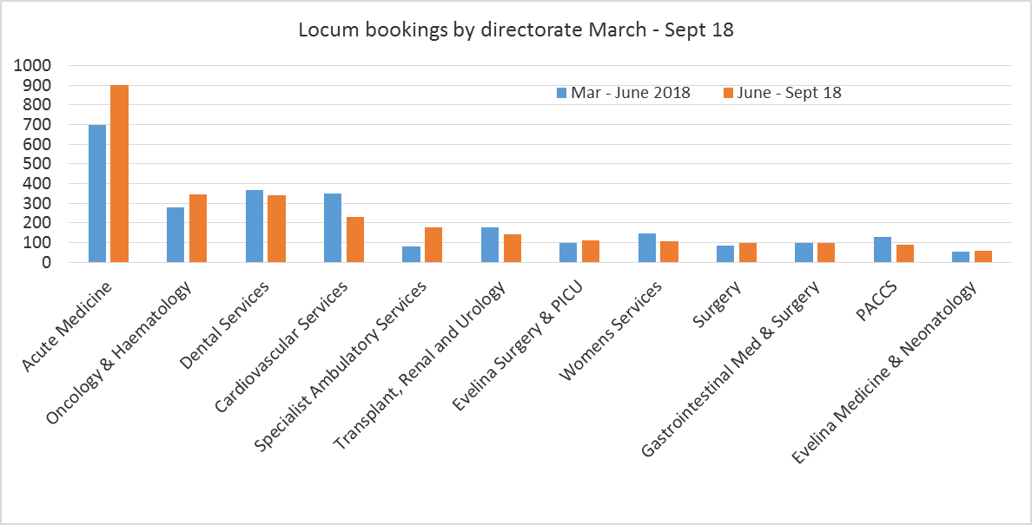

Only departments with a quarterly spend > £20,000 shown

- Locum Bookings 18th June – 16th September 2018 shifts by directorate

Directorate | Agency | Bank | Grand Total | % Bank
Acute Medicine | 188 | 713 | 901 | 79.13
Adult Community Services |  | 3 | 3 | 100.00
Cardiovascular Services | 58 | 174 | 232 | 75.00
Clinical Imaging & Med Physics |  | 14 | 14 | 100.00
Dental Services |  | 340 | 340 | 100.00
Evelina Community Services |  | 36 | 36 | 100.00
Evelina Medicine & Neonatology | 2 | 55 | 57 | 96.49
Evelina Surgery & PICU |  | 110 | 110 | 100.00
Gastrointestinal Medicine & Surgery | 1 | 98 | 99 | 98.99
Medical Director |  | 9 | 9 | 100.00
Medical Specialties |  | 32 | 32 | 100.00
Oncology & Haematology | 41 | 303 | 344 | 88.08
PACCS |  | 90 | 90 | 100.00
R&D : NIHR |  | 55 | 55 | 100.00
Specialist Ambulatory Services | 1 | 176 | 177 | 99.44
Surgery |  | 100 | 100 | 100.00
TAP |  | 24 | 24 | 100.00
Transplant, Renal and Urology |  | 142 | 142 | 100.00
Womens Services | 2 | 106 | 108 | 98.15
Grand Total | 293 | 2580 | 2873 | 89.80

- Locum bookings by Grade 18th June – 16th September 2018 shifts by grade

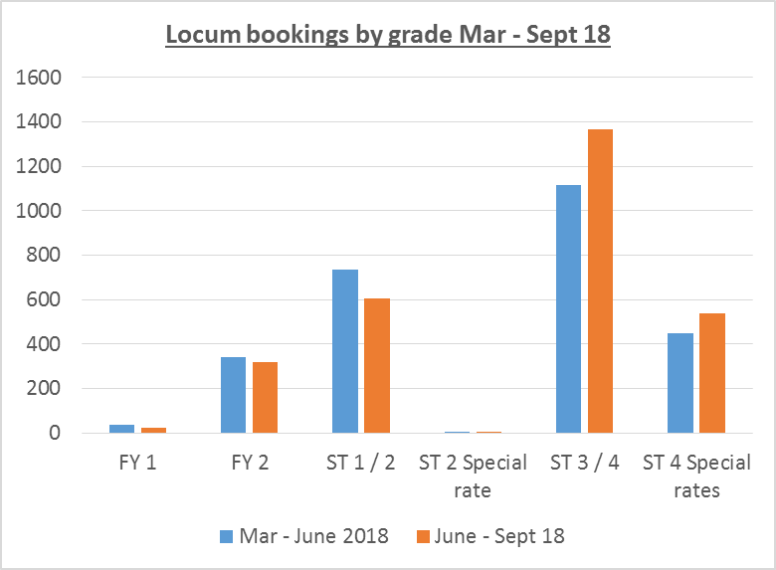
Grade Type | Agency | Bank | Grand Total
FY 1 |  | 23 | 23
FY 2 | 74 | 244 | 318
ST 1 / 2 | 46 | 559 | 605
ST 2 Special rate |  | 1 | 1
ST 3 / 4 | 171 | 1197 | 1368
ST 4 Special rates | 2 | 428 | 430
Special ED rates | 0 | 107 | 107
Staff grades |  | 21 | 21
Grand Total | 293 | 2580 | 2873

- Locum bookings 18th June 2018 – 16th September 2018 shifts by reason
Reason for Request | Agency Filled Shifts | Bank Filled Shifts | Total Filled Shifts | Proportion
Activity | 30 | 763 | 793 | 28%
Vacancy | 3 | 492 | 495 | 17%
Leave | 58 | 159 | 217 | 8%
Sickness | 0 | 5 | 5 | <1%
Research / Projects | 202 | 1161 | 1363 | 47%
Grand Total | 293 | 2580 | 2873 | 100%

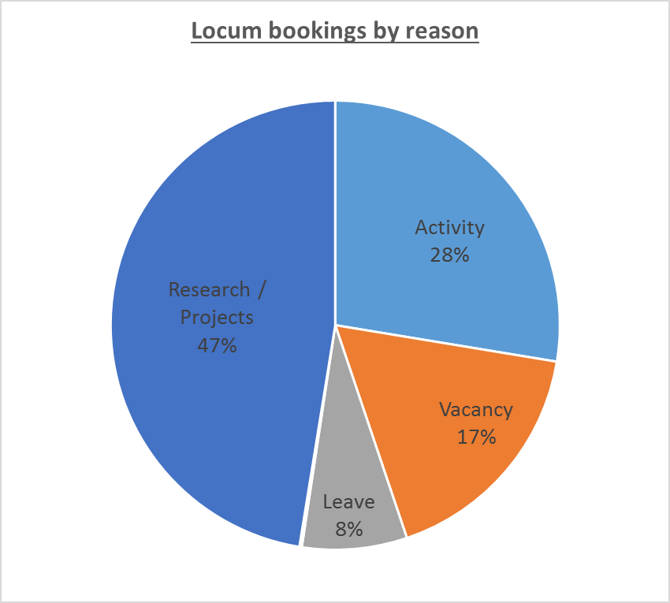

Locum bookings analysis

New locum bank rates were implemented on the 11th August, which were agreed with other trusts in the region and applied Pan London. These recognized work outside of 7am to 7pm Monday to Friday as antisocial with enhanced rates applying – See Appendix A for rate details

Total agency and Staff Bank spends and bookings have been relatively stable, rising £125K this quarter on an overall spend of £1.3M.
Of note, the locum spend in oncology rose by only £30K. Funding an additional 84 shifts in this quarter.

It is noticeable that the 6 HEE trainee vacancies in Anaesthesia were associated with only 20 additional shifts in the quarter, and an additional £15k spend. The GOSW has been made aware that Anaesthesia trainees are unwilling to work additional shifts for the locum rates applied (before or after 11th August). The department has been obliged to make informal arrangements with trainees, offering considerable periods of TOIL, to ensure continued safe coverage of the service out of hours. This has implications for trainees education and learning within their modules.

The data documents the overall number of shifts was non significantly increased (2873 vs 2683). The proportion of locum bookings filled by the staff bank increased slightly from 87% to 89%. There has been no significant change in the grade trainees undertaking locums.

The GOS has included data collected by staff locum bank on the reason for shifts being booked; there is no change in this data from the last report. As previously the GOS, staff bank, and human resources do not consider this data currently to accurately reflect the real underlying reason for the shift request and most bookings are still made retrospectively

E Locum work by individual trainees

- Locum work carried out by junior doctors who also exception reported

Department | Grade | Work schedule hrs | ER hours:  paid  no action  or open | Rota Cycle | Average contracted + reported hrs/week  (max 48) | Total Bank hours | Bank hours average per week | Average hrs/wk total (max 56) | Opted out WTR
General Surgery | F1 | 46.75 | 4 | 9 | 47.19 | 8 | 0.62 | 47.81 | Y
Vascular Surgery | F1 | 47.75 | 3 | 6 | 48.25 | 3 | 0.23 | 48.48 | Y

- Locum work carried out by junior doctors not exception reporting

(Limited to trainees working >104 Bank shift hours in 13 weeks)

Department | Grade | Total Bank hours | ATC hrs/week (Ave) | Work schedule hrs/week | Total hrs/week (Ave) | Opted out WTR | Total Hours per week  (using all annual leave)
Orthopaedics | TD Registrar level | 295 | 22.69 | 47 | 70 | Y | 65
General Medicine | TD Registrar level | 179 | 13.77 | 47.5 | 61 | Y | 57
Emergency Department | TD Registrar level | 156.5 | 12.04 | 41.5 | 54 | Y | 49
Emergency Department | TD Registrar level | 156.5 | 12.04 | 41.5 | 54 | Y | 49
ENT | TD Registrar level | 134 | 10.31 | 47.28 | 58 | Y | 53
Critical Care | TD Registrar level | 129 | 9.92 | 40 | 50 | Y | 45
General Medicine | TD Registrar level | 126.5 | 9.73 | 48 | 58 | Y | 53
Vascular Surgery | TD Core level | 115 | 8.85 | 47 | 56 | Y | 51

Analysis of working patterns of junior staff working additional shifts through staff bank.

The GOS has received confirmation that all trainees working through staff bank have opted out of the working time regulations, and are therefore able to undertake additional work up to a total of 56 hours per week on average.

The list of all 309 trainees undertaking any staff bank work in this quarter was manually cross referenced with the DRS system and the exception reporting database by the GOS.

Only two trainees were found to have submitted exception reports for additional hours, which had been closed with payment, no action taken or remained open. Neither of these trainees worked in excess of 56 hours per week on average over the quarter, when staff bank work, contracted hours and exception reports were taken into account.

One trainee in vascular surgery worked a locum shift and also exception reported in the same week. As a result they worked in excess of 72 hours in 7 days. At the time of accepting and working the locum shift, it was not anticipated that the breach would occur. However, unscheduled subsequent late finishes resulted in the trainee working 74.5 hours in 7 days. A fine was levied as a result.

A manual reconciliation of all junior doctors working in excess of 104 hours of locum work (in the quarter) revealed 8 doctors with a current substantive trust contract of work. None of these were trainees, and therefore no fines were liable. Four of these doctors worked in excess of 56 hours per week on average when contracted and locum work was combined. Two of whom (in orthopedics and general medicine) worked hours that would average over 56 per week even if utilizing all annual leave in the quarter.

Additional doctors worked more than 104 hours, but finished their contracted employment part way through the quarter. Detailed analysis revealed that locum work had been predominantly undertaken after leaving their posts at the start of August, and all of whom had worked at safe levels throughout the quarter.

The GOS recognizes that this is an analysis of work over an entire quarter, rather than tailored to the individual rota cycles of each trainee. However, whilst there is no automation of this process, or linking of the HR, exception reporting and staff bank systems, the GOS does not currently have the capacity to undertake a more detailed assessment.

As a result of the above incidences, the GOSW has liaised again with staff bank managers, to facilitate improved automation of warnings on the allocate system in order to prevent excess working prospectively.

A new mechanism has been devised, and discussions are ongoing with Allocate (staff bank software providers) to enable this to be delivered reliably.

The proposed process will also flag up to the GOSW at an early stage when a department has a large locum demand, and a small pool of juniors to take on the work. This will enable the GOSW to educate and support rota-coordinators and service managers.

No headway has been made in changing practices for booking locums, with two thirds of shifts still being booked retrospectively. Until this practice changes, preventing excess working through locum shifts will remain challenging.

Summary:
- 309 junior doctors have undertaken additional work through the trust locum bank in this period.
- 305 have done so within the safe working limit of 56 hours per week averaged over the quarter
- All doctors working locum shifts have opted out of the WTR.
- An improved process to highlight doctors undertaking unsafe volumes of locum work has been devised but is dependent on technical capabilities of the Allocate system
F. Vacancies
i. Trainee post vacancies since August changeover of doctors in training, taken from HEE records
Month | Vacancies | Grade | Department
July | 4 | ST3+ | Radiology
August | 1 | Core | Acute Medicine
August | 1 | Core | Emergency Medicine
August | 6 | ST3+ | Anaesthetics
August | 1 | Core | Anaesthetics
August | 1 | ST3+ | Sexual Health
August | 5 | ST3+ | Critical Care
August | 1 | ST3+ | Infection
August | 1 | ST3+ | Ophthalmology
September | 2 | ST3+ | Chemical Pathology
September | 1 | ST3+ | Radiology
September | 3 | ST3+ | Haematology
September | 1 | ST3+ | Paediatrics Metabolic Med

No exception reports were received in 9 of these departments with trainee vacancies over this period (in green above), despite some departments having significant gaps (6 in anaesthetics).
Of the remaining 3 departments, no trainees of the same grade reported exceptions, and no department received more than 2 reports per month by doctors at any grade.
There is therefore no correlation between known trainee gaps and exception reporting rates.
The trust currently has no mechanism for reporting vacancies on junior doctors’ rotas, and it is therefore unknown if the gaps created by the above vacancies have been adequately backfilled by trust doctors or locum shifts. The lack of a correlation is therefore to be expected.
Further discussions with Rota Map have been ongoing. Unfortunately it has not been possible thus far to extract trust wide data, which can be meaningfully correlated with exception reports. The GOSW is meeting with Rota map in November to make further progress.

G Fines

- Fines this quarter
Balance at end of last quarter | Fines this quarter | Spend this quarter | Balance at end of this quarter
£18,327.48 | £1247.22 | £ | £19,574.70

- Fines levied by department June – Sept 2018
Department | Fines levied
Oncology | £775.80
Paediatrics | £311.82
General Medicine | £74.35
Vascular Surgery | £71.40
Community Psychiatry | £13.85
Total | £1,247.22

Fines
Ten Fines have been levied and paid in the last 3 months, half of which involved the oncology department.
Seven fines were triggered due to working hours being in excess of 48 per week on average over a rota cycle.
Three fines were triggered by trainees working more than 72 hours in a 7 day period.
Seven fines related to Foundation doctors working hours and three linked to core trainees’ excess working.
- Fines Expenditure
Funds utilised | Expenditure to date
Course fees | £8493.33
Simulation | £981.00
Total expenditure to date | £9474.33
Funds Provisionally allocated | Proposed Expenditure
Vascular surgery | £3,500.00
Palliative care | £1,944.79
Oncology | £1,000.00
Reprographics | £5000.00
Provisionally allocated funds | £11444.79
Unallocated funds | £1344.42

Expenditure
Almost half of all the fines funds accrued since the implementation of the contract have been spent in this quarter.
35 doctors applied to be reimbursed (up to £200 per head) for expenses incurred presenting audit, QUIP, research or educational work. The GOSW reviewed all applications, and approved those that involved work undertaken within the specified time frame, where trainees could demonstrate presentation of their work, and for which receipts were provided (30 applications).
A further round of applications was invited, which also included those undertaking additional educational modules (involving course work). This resulted in a further 35 applications, 19 of which were approved.
Approved applications were from all grades and a wide range of departments.
Applications for funding of examination entry fees and preparation courses were not approved, as this lay outside agreed criteria, and funds would be insufficient to enable all doctors sitting examinations to be reimbursed.
The GOSW has liaised with Essentia facilities manager regarding the delivery of environmental improvements in a number of departments with ring fenced funds
Palliative Care funds are due to be spent in the next quarter supporting regional training events

H. Contract Breeches
The GOS attended the junior doctors trust induction in August 2018.
Of the more than 500 doctors rotating, 29 reported generic work schedule or operational rota issues;
- 7 Reported not receiving a Generic Work Schedule
  - 3 doctors had been sent correct GWS by HR (trainee in error)
  - 3 had not been sent due to HEE errors/late notification
  - 1 Trust doctor had not completed pre-employment checks
- 7 Reported not receiving operational rotas
  - Departments all reminded of their obligations to provide 6 weeks in advance
- 1 Reported work schedule error
  - Payment calculation on work schedule corrected by HR
- 1 Reported mismatch with work schedule and operational rota
  - Investigated by Department and HR clarified.
- 12 Reported wrong Work Schedule issued
  - 2 Correct work schedules had been sent (document title changed to clarify to trainees)
  - 4 GPVTS trainees sent wrong work schedule by St George’s HR department (lead provider)
    - Liaison with HR in two trusts to improve communication in future for trainee allocations
  - 3 Inaccurate HEE Post information
  - 3 HR errors corrected

Allergy
The GOS was contacted by ST3 trainees in allergy. They were concerned regarding a mismatch between their Generic work schedule (with no out of hours commitment), and their operational rota (which contained general internal medicine covering the medical wards.
A new work schedule review was subsequently issued, and the trainees were given the required 8 week notice period.

I. Junior Doctors Forum and Qualitative information
Junior Doctor Forum Survey June 2018
A survey was undertaken of junior doctors with the aim of improving JDF agenda content and optimizing attendance
  - Total responses 34 from 18 departments, even spread of grades
  - Preference for scheduling JDF; quarterly (65%) Tuesday (32%) late afternoon (47%)
    - Next JDF rescheduled for Tuesday 16th October 2018 (2-4.30pm)
    - 22nd January 2019 (3-5pm)
- Only 3 people had attended a forum before, and all had found it useful
- 21 (63%) were too busy clinically to attend
- The factors that would encourage attendance were;
  - Departments allocating attendance and reducing workload accordingly
  - More convenient timings
  - Departmental active encouraging attendance
- Little support for alternating between sites
- 81% would prefer a trainee co-chair, but it was not ranked highly in importance in decision to attend

- Juniors have been contacted to encourage representative elections and seeking applications for co-chair.One application has been received.

J. Update on recommendations from previous reports;

Oversight of the progress on recommendations made in GOS quarterly reports is now held by a group, with representatives from medical workforce, Post graduate medical education and the chief operating office, as well as the GOS. The action log is held by the Head of Medical Education Programmes.
Progress on the recommendations from previous reports can be found in the table below. Progress currently is on target with delivery schedules for all except one recommendation, an update has been requested..

No | Action |  | Responsible Individual(s) |  | Update |  |  | Date Due |  | RAG |  | Open / Closed
3 & 8 | The GOS again advises the staff bank to limit trainees who have a contract for regular work to a maximum of 104 hours of work per quarter or similar process to limit trainees hours <56/week. |  | Pauline Flockhart |  | Further discussions between the GODW and Staff Bank. Awaiting system improvements from Allocate to enable more reliable delivery.  Full implementation is problematic due to the proportion of shifts retrospectively booked. |  |  | Jun-18  Dec-18 |  | On target |  | Open
4 | The trust should actively discourage departmental clinical and educational lead posts being held by the same person in departments. There is often a tension between these roles. Supporting trainees whilst undertaking both roles is an unnecessary challenge |  | Rob Godfrey Claire Mallinson  MDO (Kate Langford) |  | -Educational Lead JD to be reviewed by CM to include statement of incompatibility with Clinical Leads role - Completed  -Clinical Lead JD to be reviewed by MDO to include statement of incompatibility with educational lead role. - Completed  -Lead in care of the elderly no longer holding both posts.  - Lead in Oncology to relinquish lead role shortly  -List of both incumbents needs to be up to date and visible to HR and GOS (for work schedule compilation). MDO and PGMC to arrange. No progress this quarter. |  |  | Aug-18 |  | On target |  | Open
No |  | Action | Responsible Individual(s) |  | Update |  | Date Due |  | RAG |  | Open / Closed
9 |  | The trust should devise a process for managing operational rotas for doctors around rotation times, to prevent shift clashes when moving from one department to another. |  | Max Tolhurst  Rob Godfrey |  | RG met with India Brumitt, Louisa Stockmanvine 01.05.2018  Draft documentation to be shared with other service managers. No update this quarter.  HR and PGME have set up an Induction working group to review issues around rotations and induction | Aug-18 |  | Overdue |  | Open
10 |  | The GOS again advises the board to explore the costs and potential advantages of the alternative exception reporting system (Allocate). |  | Pauline Flockhart / Jennifer Allan |  | Jen Allen is currently overseeing the implementation of Medi Rota. Once this is in place across the trust and the requirements of all systems is known, alternative electronic systems can be assessed. | Jan-19 |  | On target |  | Open
11 |  | All educational and named clinical supervisors should include data demonstrating their timely management of exception reports in their forthcoming annual appraisal. |  | Claire Mallinson |  | -GOS spoken to Director of Medical Education for approval (completed)  -Educational supervisors to be advised in training for need and process of exception reporting (Completed May 2018)  -ES appraisal to include the number of exception reports managed and closed by an ES | May 2018  Jan 2019 |  | On target |  | Open
No |  | Action |  | Responsible Individual(s) |  | Update | Date Due |  | RAG |  | Open / Closed
2 |  | The ability to provide monitoring data for rota publication rates 6 weeks in advance of placements should be a requirement for any electronic rostering system purchased by the trust |  | Jennifer Allan / Ian Rothwell |  | Jennifer Allan to investigate the capability of Medirota to be searchable  GOS contacted RotaMap. Technical possibilities to be developed. (Meeting Scheduled 5th Nov 2018) | Feb 2019 |  | On target |  | Open
12 |  | The trust should review the performance of the designated hospital transport taxi service for all staff groups finishing shifts at unsocial hours |  | Sarah Webster (left trust), Peter Bennett  Joe Chappel |  | The current taxi service is due to go out to tender. In the meantime, a performance review will be carried out and issues picked up with the supplier. Current system does not delineate between patients and staff bookings or allow calculations of waiting times. No further update has been received this quarter | TBC |  |  |  | Open
13 |  | The GOS recommends the trust provide additional resources (medical, administrative or pharmacy) to Oncology department to relieve the workload for Foundation and Core trainees in the short term, whilst physician associate staff are appointed and trained |  | Anna Rigg, Sarah Rudman,  Simon Steddon |  | Two junior doctor locum appointments have been funded and appointed to covering October and November  Given the failure to appoint physicians associates these posts may need to be extended, and should in any case cover the PA training period | August 2018 |  | On target |  | Open
No |  | Action |  | Responsible Individual(s) |  | Update | Date Due |  | RAG |  | Open / Closed
14 |  | Medical Workforce to provide data on the cost of exception reports settled through payment as well as the total cost of fines payments to enable feedback to departments and trust wide oversight |  | Pauline Flockhart |  | HR able to provide total cost of fines information on a monthly basis.  Process for automation of total cost of exception reporting being devised | Dec 2018 |  | On target |  | Open
15 |  | All new rota coordinators should meet with the GOS during their induction to the post, to ensure they are aware of the terms of the contract and to create a strong link |  | GOSW, Service Managers |  | GOSW has made service leads and general managers aware of need to link new appointees with GOSW. Training sessions under way for current staff.  In discussion with HR to ensure GOSW notified of all new JD coordinator appointments | Dec 2018 |  | On target |  | Open

Appendix A - JUNIOR DOCTOR BANK RATES Information to trainees (8th August)
From Saturday 11th August new bank rates will be paid to junior doctors working bank shifts at Guys and St Thomas’.
The rates will be aligned with the max Local London rates, which all other London Trusts have agreed to implement.
Separate higher rates will be paid for unsocial hours (Monday – Friday 7pm – 7am and weekends and bank holidays).
PAN LONDON GRADE | SHIFT | PROPOSED NEW GSTT BANK RATE inclusive
FY1 | Day | £22.41
FY1 | Unsocial | £26.90
FY2 | Day | £33.62
FY2 | Unsocial | £40.35
ST1/2 | Day | £35.86
ST1/2 | Unsocial | £43.03
ST3+ | Day | £44.83
ST3+ | Unsocial | £53.79
Speciality Doctor/Staff Grade (ST6/7) | Day | £50.43
Speciality Doctor/Staff Grade (ST6/7) | Unsocial | £60.52
HTF Spec - hard to fill  (limited periods only) | Day | £56.04
HTF Spec - hard to fill  (limited periods only) | Unsocial | £67.24
A&E Dark green | Day | £60.52
A&E Dark green | Unsocial | £67.24

